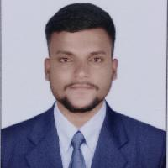
Abrar

0504753686 | Abrar-399233@2freemail.com

Objective

To enhance my professional skills, capabilities and knowledge in an organization which recognizes the value of hard work and trusts me with responsibilities and challenges.

Education

ANWARUL ULOOM COLLEGE OSMANIA UNIVERSITY HYDERABAD
BACHELOR OF COMMERCE | July 2019
Experience

2018 - 2020
Responsible for getting the right products in the right quantities, to the right locations all at the right time.

In charge of the day to day operations of the transport department.

Eﬃciently managing a team of drivers and vehicles.

Responsible for all of the dispatching, routing, and tracking of delivery vehicles.

Skills

-Thorough knowledge of Accounting

-Written and communication skills,

-Ability to deal with people diplomatically,

-Tally, Accounting ,MS-Excel

-Active listening

-Communication

-Computer skills

-Customer service

-Time management

Language

ENGLISH

HINDI

TELUGU

Activities

PARTICIPATE IN ALL INDIA INDUSTRIAL EXHIBITION

Personal Details

Date of Birth | : | 15/07/1997
Marital Status : |  | SINGLE
Nationality | : | INDIAN
Age | : | 23
Gender | : | Male

Interests

Playing sports (football, tennis, etc.)

Reading and writing books articles

Drawing, sketching and painting

