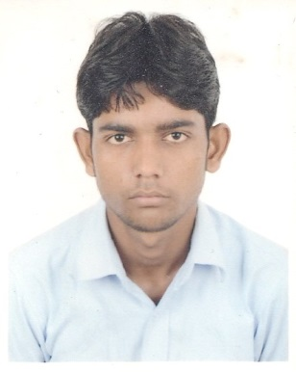
CURRICULUM VITAE

NOMAN
Mobile No: 0504753686
E-Mail: noman-399418@2freemail.com
- DATE OF BIRTH:02/02/1995
- SEX: MALE
- RELIGION:MARRIED
- MARITAL STATUS:SINGLE
- NATIONALITY:INDIAN
- VISA STATUS:
EMPLOYMENT VISA
- JOINING AVAILABITY:
IMMEDIATELY

AC DUCT FITTER & FABRICATOR
Objective:

Seeking To Fill The Challenging Position Of A In An Organization Which Is Growth Oriented And Helps Me Contribute To The Success Of The Organization Along With My Personal Growth.

Qualification:

* I HAVE NO FORMAL QUALIFICATION, BUT I HAVE MORE WORKING EXPERIENCE

Work experience:

- Working as anAC DUCT FITTER & FABRICATOR at DUBAI, UAE since 3 years 6 months till now.

- Worked as an AC DUCT FITTER & FABRICATOR at GEOGROA ENGINEERING PVT LTD, INDIA since 1 year from 2016 to 2017.

- Worked as anAC DUCT FITTER & FABRICATOR at ACES INDIA PVT LTD since 1 year from 2015 to 2016.

- Worked as anAC DUCT FITTER & FABRICATOR at SUVIDHA ENGINEERING INDIA PVT. LTD, INDIA since 1 year from 2014 to 2015.

Language:

HINDI , URDU &ENGLISH(BASIC)

Technical Skills:

* Expert in AC - Duct , GI, PI, CLIMAVER fitting and fabrication works.

Declaration:

I Hereby Declare That, All The Details Given Above Are True. I Assure That I Will Abide The Rules Of The Organization Be And Truthful In My Duty.

NOMAN

