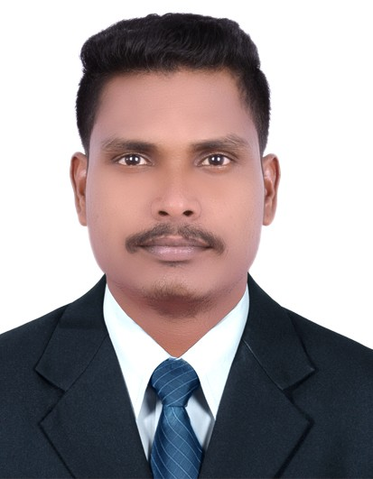Arun
Phone 0504753686
Email arun-399428@2freemail.com

Professional Summary

Highly skilled Fabrication supervisor with 8 years of experience supervising, scheduling and directing employees. Resourceful specialist, knowledgeable in the production of steel. Focused on monitoring safety in a busy and potentially hazardous environment.

Work Experience

08/2018-02/2019

DUBAI
FABRICATION SUPERVISOR
- Planning, job execution, reviewing of weekly progress and getting done the job with the minimum resources.
- Worked on: supply vessels, passenger vessels, pontoons, dredgers and cargo vessels structural steel fabrication and erection.
- Shipbuilding and repairs on various vessels and pipe racks and spool fabrication, installation and commissioning.
- Ship Repairs(steel renewal, outfitting repair, and renewal)
- Responsible for the planning and coordination of all manpower and equipment.
- Monitoring and maintaining manpower factor within the target.
04/2017-05/2018

HEAVY ENGINEERING INDUSTRIES AND SHIPBUILDING CO. KSC., KUWAIT
FABRICATION SUPERVISOR
- Fabrication of pipe sleeper, pipe shoe, Teflon pads as per standard drawings.
- Fabrication of heavy HEB, HEA beams and UPN for the Debottleneck projects.
- Cross-check the dimensions and elevations.
- Handled the manpower deployment.
- Raise the quality inspection report and RFI reports.
- Responsible for safety and Quality job activities.
- Leads efforts to develop and deploy standard work for each work area.
- Coordinates fieldwork with project managers and customer/plant representatives.
- Creates a work order for each job and plan/track labor and materials.
- Monitor scrap and re-work levels and work with the team to identify the root cause and determine a corrective action plan.
04/2016-02/2017

RAREFIELD ENGINEERS PVT LTD, CHENNAI
STRUCTURAL STEEL SUPERVISOR
- Planning, job execution, reviewing of weekly progress and getting done the job with minimum resources.
- Involved in Ship Repairs, Building and Conversion.
- Monitoring and maintaining manpower factor within the target.
- Responsible for the Safety and Quality of job activities

08/2015-02/2016

RAREFIELD ENGINEERS LLC, DUBAI
PRODUCTION SUPERVISOR
- Identified steel repairs in the vessel that shown from the client.
- Prepared the confined space work area with light and ventilation to get hot work and confined space permit.
- Monitored materials used to identify concerns and keep costs low.
- Boosted production throughput and quality by revamping procedures and monitoring strategies.
- Minimized resource and time losses by addressing employee or production issues directly and implementing timely solutions.
- Evaluated team member performance every timeframe to identify and resolve productivity concerns.
- Reduced inventory and monthly team labor hours by strategically updating processes and reorganizing operational workflows.
- Attend an onboard meeting with the Client.
02/2013-06/2015

KAARUNYAN ENTERPRISE, CHENNAI
SUPERVISOR
- Ship repairs and truss fabrication works.
- Monitor / inspect the quality of workmanship.
- Solve work delivery problems as they may arise.
- Supervise multiple technician/artisans workgroups throughout the day.
- Commit to delivering the agreed weekly schedule/look ahead schedule as issued by the scheduler/client.
- Report progress to Operations / the Scheduler / Client each day
- Complete timesheets each day.
08/2011-10/2012

RAREFIELD ENGINEERS LLC, DUBAI
STRUCTURAL STEEL SUPERVISOR
- Ship and Rig Repairs (Steel renewals, outfitting).
- Involved in the new shipbuilding projects of the 67 m PULLAHTS Tug Vessel.
- Lead the fabrication team in Risk Assessment/Safe start card evaluation in all work delivery functions.
- Provide comment and input into the weekly schedule/look ahead schedule as drafted by the scheduler/client.
- Ensured all materials used and performed as per specifications.
- Support with Project Staff.
- Prepared relevant SRM documents in conformance with the Safety Management System (SMS) order.
- Managed quality assurance program including on-site evaluations, internal audits and customer surveys.
06/2009-06/2011

ADVENT INDUSTRIAL PROJECTS, CHENNAI
PRODUCTION ENGINEER
- Railway Coach manufacturing and repairing.
- Design the coach frames as per the requirements and oversaw fabricated frames.
- Commissioning the fabricated frames.
- Reporting the project status to the management and report the management from fit-up inspection to final client work done report.
- Created engineering documentation, including manufacturing processes, equipment specifications, and change notices and implemented modifications depends upon Client requirements.
- Supervised the entire production process and prepare proper documentation for dispatch.
- Performed root cause analysis and implemented corrective actions as required.

Education

06/2005-06/2009

DR.NAVALAR NEDUNCHEZIYAN COLLEGE OF ENGINEERING, CUDDALORE
(MECHANICAL ENGINEER)

Languages

ENGLISH — Very good command
HINDI — Very good command
TAMIL — Native speaker

Additional Skills

    - Project presentations
    - Teamwork skills
    - AutoCAD
    - Fluent in English, Hindi, Tamil.
    - MS Office
    - Problem-solving
    - Quality assurance
    - Document control

Knowledge Known

- Knowledge in erection of steels, Tanks, Platforms, and Foundations, etc.
- Good Knowledge in Welding (SMAW, FCAW)
- Knowledge in plans, drawing and quantities for accuracy of calculations and commercial wise.
- Knowledge in Risk Assessments for Health and Safety.
- Knowledge in Commercial and Document works.
- Knowledge in Rigging and loading.

Personal Details

Full Name : ARUN KUMAR
Sex : Male
Date of Birth : 21 JUNE 1987
Hobbies : Reading News Papers, Books.
Languages Known : English, Hindi, Tamil, and Malayalam

Declaration
I hereby declare that the information furnished above is true, correct and complete to the best of my knowledge.

