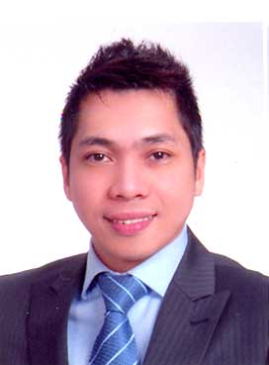

JEFFREY

Mobile# 0504753686
Email: jefferey-399464@2freemail.com

JOB OBJECTIVE:
To be able to work effectively in a company and the opportunity to provide outstanding performance that will help company’s goals & missions.

EMPLOYMENT HISTORY
Dubai Duty free
P.O. Box 831Dubai International Airport
Dubai, United Arab Emirates
Sales Assistant/ Beauty Advisor
July 2005 –2006 Sales Assistant :Cashiering, merchandising, promoting products
Link selling
Dec 2006 – present Beauty Advisor
Cash handling, display and sales

Influent Inc.
8/F Robinsons Equitable tower, cor. ADB Ave.,
Ortigas, Pasig City, Philippines
Customer Contact Associate
June 2004 – May 2005Handled Inbound and Outbound Sales to American based clients
- Provides and Promotes customers with products and services offer through the telephone
- Building Rapport interaction with prospective clients
- Research required information using available resources
- Complete Call logs and reports

Megacall Inc.
35/F RufinoPacificTower, Ayala Ave.,
Makati City, Philippines
CallCenter Agent
March 2003 – March 2004 Handling Outbound Calls to Japan
Selling and promoting prepaid cards to possible customer
Over the phone.
Sales driven and goal oriented

Philippine Science & Technology Centers
3/F ConradoBldg,Aguinaldo Hi-way,
Bacoor, Cavite City, Philippines
Marketing Assistant
Jan. 2001 – Feb 2003 Front desk receptionist, answering phone querries about
Courses in school, doing Career orientation in front of
Upcoming college students, promoting the school and helping
Marketing the school.

ON THE JOB TRAINING

Gulf Air Cargo, 2/F Pair Pags Airport Rd, Paranaque City, Philippines
Nov. 1998 – Feb. 1999

Personal Information

Nationality: Filipino
Gender: Male
Civil Status: Married
Height: 5’ 10 “
Weight: 155 lbs.

EDUCATION:

College Degree
UNIVERSITY OF THE EAST, Samson Rd. Caloocan City, Philippines
BACHELOR OF SCIENCE IN BUSINESS ADMINISTRATION
Major in Marketing
Dec 6, 2000

SEMINARS ATTENDED
CREATIVE ENTREPRENEURSHIP
October 25-26 2001
University of the Philippines, Diliman, Quezon City, Philippines

PERSONALITY DEVELOPMENT
Aug 5, 1999
UE Auditorium, Caloocan City, Philippines

CHARACTER REFERENCE – available upon request

