CURRICULUM VITAE
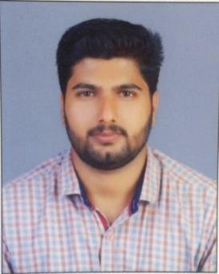

PRESENT CONTACT
VINAYA
TEL: +971504753686
Email: vinaya-399467@2freemail.com

CAREER OBJECTIVES

I am looking for the challenging job where I can utilize my talent and knowledge, I want to learn from the organisation and growth with organisation.

PROFESSIONAL QUALIFICATION

- Diploma in fire & safety engineering from ITEC

- IOSH

- Basic first aid

- Basic fire fighting

EDUCATIONAL QUALIFICATION

- Higher Secondary school -State board of Kerala, India

- Degree From University Of Kerala

- Diploma in PC Hardware &Networking

WORK EXPERIENCE

- Dolphin System Ernakulam( 2year) CCTV Technician

  - Packaging Products Manufacturer based in Kuwait From (November 2018)- Current Employee Machine Operator

COMPUTER KNOWLEDGE

- MS office

- MS excel

STRENGTH & ABLITIES

- Able to work under pressure

- High level of interpersonal skills

- Confident of managing any situation independently

- Able to communicate fluently
- Team Spirit and Enthusiastic

LANGUAGES KNOWN
Malayalam, English, Hindi, Tamil

PERSONNEL DETAILS

Date of | Birth | : 07/06/1994
Marital | status | : | Single
Nationality |  | : | Indian

DECLARATION

I do hereby declare that the above mentioned facts and information are correct to the best of my knowledge and belief. I assure you that if I am being selected for your esteemed organization, I’ll work hard and sincere up to your Satisfaction.

Thanking you!

_{Place:} _{India} Yours Sincerely

Vinaya

