Aiswarya
Click here to buy CV Contact:
http://www.gulfjobseeker.com/employer/cvdatabaseservice.php

To work for an organization which provides me the opportunity to improve my skills and knowledge for personal growth alongside achieveing the organization's objective. Eager to learn new technologies and methodologies.

Professional Experience

Project Leader / From 2017 to 2018

Smart Zone Based Vehicle Speed Control & Accident Prevention

Project Summary:-

This Vehicle is a miniature with electric motor and a driver, having many advantages which influence our day to day practices. It controls the speed of the vehicle entering into a speed restriction zone. It stops automatically in case of an obstacle detection. A message will be send to the police control room or any number given say emergency number about the accident and it's location in case of occurrence.

Project Experience:

>Handled the operation and maintenance of the module.

>Lead the designing, maintaining, implementing, or improving electrical instruments, facilities, components, equipment products and systems involved in the module. >Ensuring compliance with specifications, codes, by directing or coordinating installation, manufacturing, construction,

maintenance, documentation, support or testing activities of the module.

>Preparing specifications for purchases of electrical equipment and materials.

>Supervising and training project team members.

>Writing reports and compiling data regarding the module and conducting test studies of failure/success report and compiling the same.

Project manager Cochin University of Science and Technology Kerala / From October 2016 to March 2017

Speed Control Of Single Phase Induction Motor Using Back to Back SCRs

Project Summary:

Speed of Single Phase Induction motor is reduced with a highly effective and efficient method.

Project Experience:

>Leading the team which confirms motor capabilities by designing testing methods; testing properties.

>Assures product quality by designing testing methods; testing finished products. >Prepares product reports by collecting, analyzing, and summarizing information, test reports, data etc.

>Maintains professional and technical knowledge along with the team by attending workshops; reviewing publications; establishing personal networks; participating in professional societies etc.
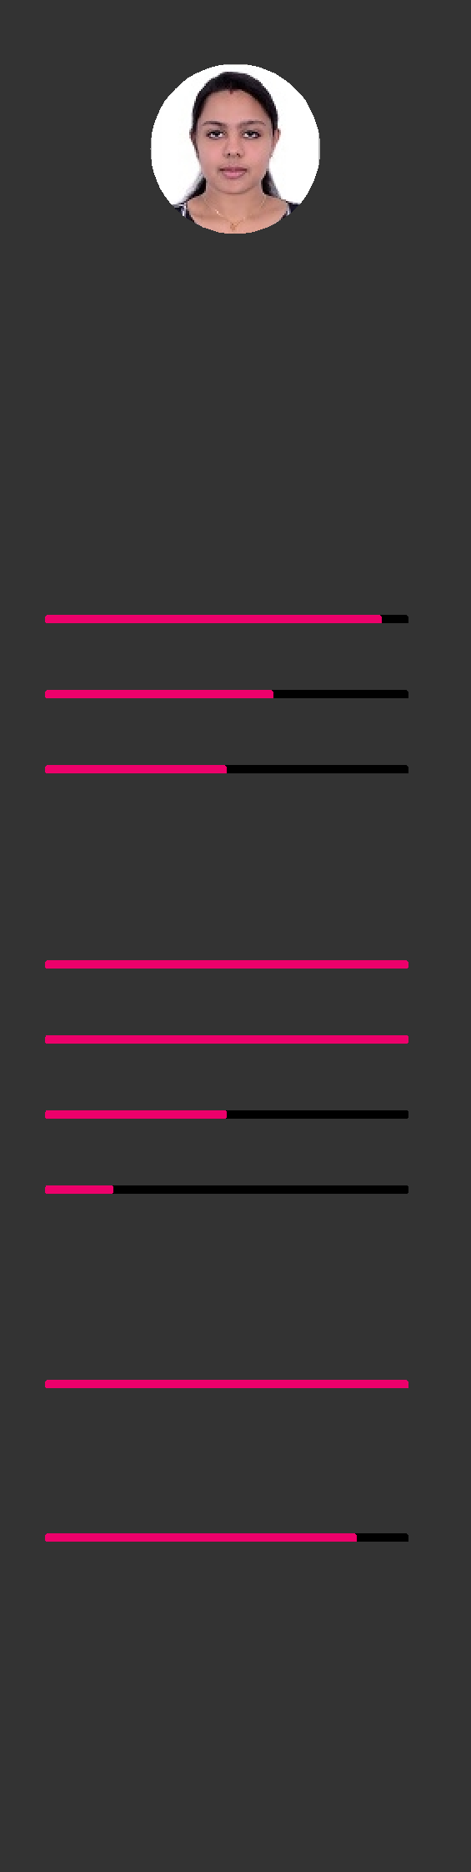

Email: Aiswarya-399472@2freemail.com

Whatsapp No. +971504753686

Date of birth 02/24/1996 Indian

Computer skills

MS OFFICE

MATLAB

PSPICE

Languages

English

Malayalam

Tamil

Hindi

Assets

Certificate of Merit (2018)

Achieving the highest score in B.Tech, X11th and Xth from Alappuzha Dist. Co-op. society Ltd

Certificate of Excellence

Awarded for completing Swarm Robotics, workshop conducted by Technophilia Systems in association with Robotics&Computer Applications Institute of USA.

/

Education

B.Tech in Electrical & Electronics Engineering Cochin University of Science and Technology Chengannur, Alappuzha, Kerala, India / From June 2014 to April 2018

Successful completion of B.Tech Degree with a CGPA of 8.57

High School Amrita Vidyalayam (CBSE) Pandalam, Pathanamthitta, Kerala, India / From June 2000 to March 2014

Voluntary experience

Seminar CUSAT Kerala / 2017

Triggered Current Limiter

Arc flashes and the damages caused can be effectively controlled by means of this Triggered Current Limiter. It is the best way to reduce personal hazard in addition to equipment.

Internship KSEB Kerala / 2015

Five day internship on a 220 kV electric substation.

Skills

Organizational Skills

Solid organizational skills with ability to multi task, work under pressure, coordinate multiple projects simultaneously and meet deadline under stringent time constraints.

Adaptability and Creativity

Ability to balance workload efficiently. Analytical and able to work in constantly changing environment.

Detail oriented and Efficiency

Ability to work in a team under pressure and produce desired results within efficiency and attention to detail.

Leadership, Decision Making

Technical lead of EEE department for 2 years, representative in technical activities and various organization.

Teamwork, Time Management, Adaptive

Successful completion of multiple projects within the frame and parameter.

Interests

Listening music

Internet browsing

/

