SAFEER

Project Engineer

Safeer-399510@2freemail.com

+971 504753686

TECHNICAL SKILLS

Auto Cad

MS oﬃce word

Ms oﬃce Excel

INTERESTS

Site Execution

CAREER OBJECTIVE
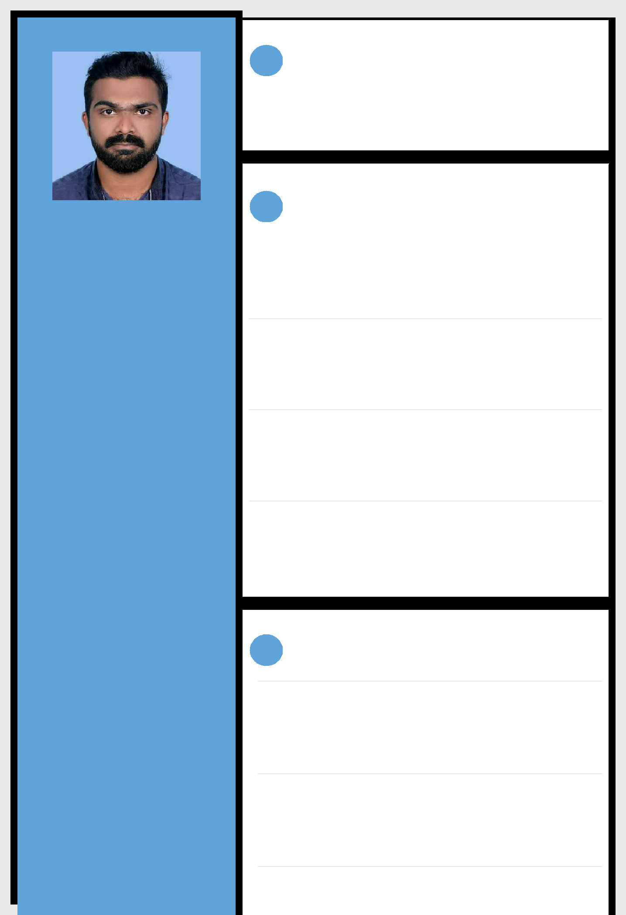

To obtain a position that will enable me to use my strong organizational skills, award-winning educational background, and ability to work well with people.

 EXPERIENCE

Project Engineer

12/06/2020 - 05/10/2020

Site Execution, Quality Checking,

Al Turki Enterprise LLC Oman

Site Engineer

12/11/2017 - 04/03/2020

Site Execution, Quality Checking

Historic Homes Pvt Ltd

Project Engineer

15/06/2015 - 06/11/2017

Project Execution , Quality Checking, Contractor s Bill checking

Selmec Engineering Construction

Site Engineer

02/05/2013 - 06/06/2013

Site supervising, Man power Handling, Dealing client's

EDUCATION

EXCEL POLYTECHNIC COLLEGE

Diploma in civil engineering

2013

GVHSS MEENCHANDA

Higher secondary education (VHSE)

2010

GVHSS CHERUVANNOOR

Secondary school (SSLC)
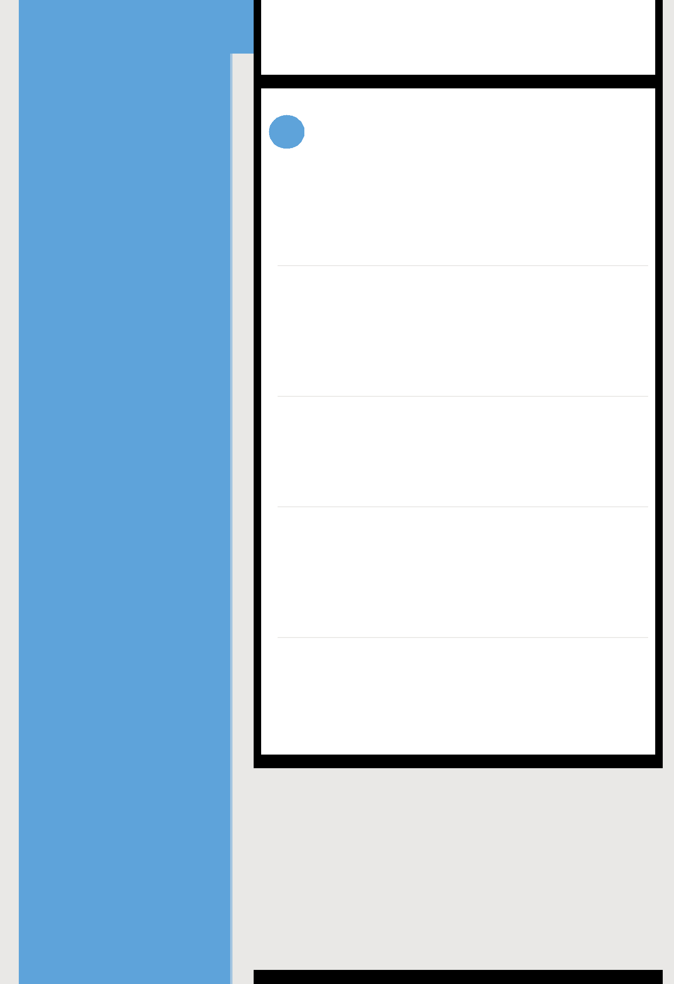

2008

PROJECTS

Commercial complex project at Kerala

4 Month

Piling work, Pile cap casting, etc for commercial complex project at Kerala

Oil & Gas Project (PDO) at Oman

2 Year 4 Month

Construction of residential & commercial buildings, Location preparation for Rig installation, Sleepers erection & Raod construction, Oil seprater Tank casting. etc

High rise building project at Kerala

2 Year 4 Month

Construction of High rise Residential building, swimming pool construction & Land Scape for Resort project.

Delhi Metro Rail Project(DMRC) at Delhi

1 Year 2 Month

Construction of Pile Cap, Pire,Pire cap, I Girder (pre- tension & Post- tension), U Girder casting & Casting yard Development ,etc

Chennai to Tada six Lanning Road project( L&T)at Chennai 1 Year
Constructions of Retaining wall, Diaphragm casting, I Girder erection, Deck slab casting,Box culvert casting. etc

PERSONAL PROFILE

Date of Birth | : 19/05/1992
Marital Status | : Married
Nationality | : Indian

Known Languages : English, Malayalam, Hindi, Tamil, Arabic

DECLARATION

I do here declare that the mentioned above are true to the best of my knowledge and belief

Date : 08/10/2020

Place : Dubai

SAFEER

