Curriculum Vitae
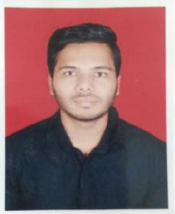

Name - Saurabh

Mobile - 0504753686
Email ID – saurabh-399511@2freemail.com
Date of Birth- 18thAugust 1995.
Marital Status- Single.

Job Objectives

To work in an organization that provides a conductive environment and continuous scope for professional growth where my intrinsic knowledge and acquired skills can honored for mutual betterment.

Work Experience – (1 Year)

- Currently working in Quality Control (Microbiology) department as a Trainee from October 2019 till date.

Work Skills :

- Perform media preparation and growth promotion test.

- Perform sampling and testing of water.

- Perform microbial limit test of raw material, finished products as per standards.

- Perform MLT validation.

- Perform culture maintenance.

- Perform bacterial endotoxin test.

- Perform environmental monitoring in sterile and non sterile area.

- Maintain documents as per good documentation practices.

Education Details

Course | University | Year of Passing | Percentage
M.Sc (Microbiology) | Pune University | 2019 | 58.20%
B.Sc(Microbiology) | Pune University | 2016 | 61.52%
H.S.C. | Maharashtra Board | 2013 | 54.00%
S.S.C. | Maharashtra Board | 2011 | 61.60%
D.M.L.T. | Mumbai University | 2017 | 67.00%

Extra-Curricular Activity

- Poster Presentation in National Conference on Green approach towards Environment and Chemical Science at Narayangaon, Dist-Pune.

- Poster Presentation in UGC Sponsored National Conference on “Innovative Ideas and Research in Life Sciences for Sustainable Development”.

- Attended National Conference On” Advances in LifeSciences”

- Disseration Project work done on Application of keratinous waste towards sustainable development.

Languages Known

- English

- Hindi
- Marathi

Professional Skills

- Good communication skills
- Able to work in a team.
- Focus towards goals.
- Rapid learner with strong grasping approach.

Computer Knowledge

- Power Point.
- Internet Knowledge.
- MS Office, MS Word, MSExcel

Declaration

I hereby declare that all the information mentioned above is correct to the best of my knowledge and belief.

Saurabh

