CURRICULUM VITAE
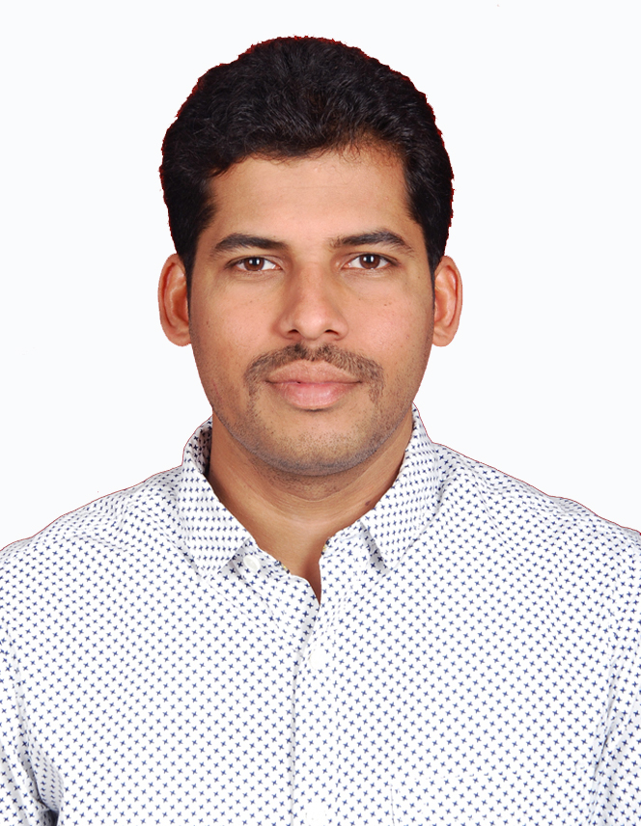

Guruprasad

0504753686
Guruprasad-399517@2freemail.com

Career Objective:To become an excellent Civil Engineer taking up Challenging Works in Industrial structures, Buildings etc. with creative and diversified Projects & to be part of a Constructive & Fast Growing World.

Experience:10+ years

Profile Summary
- 10 years of experience in Construction Industry.
- A Civil Engineering degree from NMAMIT NITTE [Karnataka, India]
- Various certifications like AutoCAD, Revit Architecture, 3dsMax, Primavera etc.

Professional Experience

Organization: currently working from march 2016.

- PROJECT: “Wahat Al Zaweya”Al Ain
Scope of the project is to make Roads and infrastructure (Sewerage line, Strom Water line, Potable water line, Irrigation water line & Telecommunication Line)

Designation: Site Engineer.(working since July 2019)

Roles and Responsibilities:

- Follow up of activities includes excavating trench and laying of pipes, installation of manholes, connecting short pieces and finish the hydro test and deflection test to backfill and achieve the formation level to start the asphalt road work.
- Planning the work and organizing the site facilities, equipments and follow up of materials in order to meet agreed deadlines
- Follow up of work with sub-contractors site team in daily basis to achieve the target and close the RFI.
- Regular meeting with sub-contractor to achieve the target.
- Preparing daily project report and reporting it to section engineer.

- PROJECT: ”Al dabiya surface facilities phase 3”(oil and gas sector under ADNOC) Abu Dhabi
Designation: Site Engineer.(March 2016-july2019)

Roles and Responsibilities:
- Completed a electrical substation building and transformer bays from foundation level to finishing level includes block work, plastering, painting, tile & rubber flooring, MEP work as per approved drawing and method statement.
- Excavation and construction of piperack foundations.
- Excavation and installation of precast manholes & cable trench for underground facilities.
- Landscape work includes Road works, sub base course, kerb stone & interlock works, preparation of road shoulders, excavation and installation of precast light pole foundations, installation of boundary fence.
- Estimation for quantities of materials to be ordered and follow up of materials to avoid delay of work.
- Reporting Qc to raise RFI for each activities and follow up to close the RFI without delay.
- Planning and reporting to section engineer on regular basis.
- Regular follow up with subcontractors to finish the work in time and quality.
- Working as job performer under e-ptw system.
- Assigning and control the work team with regular meetings.

Organization:M/s. AliShar contracting corporation (Saudi Arabia), from March 2014 to august 2015.

Designation: Site Engineer.

Project:“ABHA HOUSING PROJECT” A Infrastructure work for housing includes piping, electrical and road works.

Roles and Responsibilities:
- Earthwork excavation and backfilling to reach formation level.
- Survey work using total station and dumpy level
- Field tests as per quality requirements.
- Installing sewage and water pipelines as per approved drawing.
- Shuttering, reinforcement and concrete works for retaining wall.
- Road work including sub grade, sub base, base and top course(asphalt) as per design.
- Follow up of machineries to complete the work in time and control the cost.

Organization:Malpe Manipal Builders Pvt.ltd, from august 2011 to march 2014.

Designation: Site Engineer.

Project:“Royal Embassy” 30 storey residential project as well as G+6
commercial project.

Roles and Responsibilities:
- Planning and Execution of work as per design & drawing with quality.
- Execution ofReinforcement& shuttering work as per approved drawing.
- Concrete works for the structure with designed grades as per structural requirements.
- Following up compressive strength of concrete for 7, 14 and 28 days.
- Block masonry and plastering work as per drawing.
- Installing MEP works as per drawing.
- Follow up of ordered materials to receive on time to work without delay.
- Preparation of daily, weekly, monthly, reports of work progress.

Organization :T.R. RAJAN CONSTRUCTIONS BANGALORE, from august 2010 to august 2011(1 YEAR)

Designation: Site Engineer.

Project:Structure of 10 storey commercial project with Multi Level Car Parking“Exora Business Park”MarathalliBangalore (PRESTIGE GROUP)

Roles and Responsibilities:
- Execution of structural work(Reinforcement, shuttering & concrete) from foundation to slab level as per approved drawing.
- Planning and arranging manpower for the work on daily basis.
- Pile reports and eccentricity checking for the installed pile foundations.
- Preparing and submitting bar bending schedule and bills.
- Block masonry and plastering work for the structure.
- Installing MEP works as per drawing.
- Coordination with Clients/Consultants on regular basis.

Educational Qualification: Bachelor of Engineering [B.E]
Branch : Civil Engineering
College : NMAMIT NITTE,Karkala, Udupi, India
University :Visvesvaraya Technological University, Belgaum, India
Year of Passing : 2010 (2006-2010) Batch
Grade : First class [62%]

Major
Final Year Project : “Studies on development and management of a typical water shed”
Industrial Training :“Nirmithi Kendra” at surathkal

Others:
- Awarded withbest supervisor award by Tecnimont pvt. Ltd. in 2016.
- Awarded best project of the year at Expro2010, NMAMIT NITTE for the project of studies on development and management of a typical water shed.
- Participated in ‘Feel employable’ undertaken by college for leadership and human resource development.
- Four day technical training program on Total Station Surveying and Stad-Pro organized by department of Civil Engineering Nitte.

Professional Licenses:

- Licensed Building surveyor : License by Town Municipality ( India)
- Driving licenses : UAE, Saudi Arabia, India.

Strengths
- Excellent team player with an ability to manage and motivate teams in delivering positive results
- Excellent negotiation skills
- Good communication and interpersonal skills
- Internal drive to perform and get results
- Quick learner with an ability to grasp new technologies with ease
- Good Analytical & Problem Solving skills
- Ability to take up responsibilities in order to achieve desired goals and objectives

Personal Details

Date of Birth :5th January 1989
Gender : Male
Marital status :married
Nationality : Indian
Languages I know : English, Hindi, Kannada,Arabic (intermediate)

Place : Al Ain
Date :11 oct 2020

(Guruprasad)

