NIKHIL
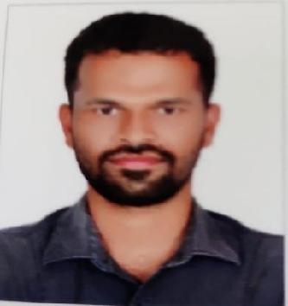

DOB: 15-07-1991

PHONE: 0504753686

EMAIL: Nikhil-399522@2freemail.com

CAREER OBJECTIVE

Seeking a position to utilize my skill sets in the mechanical sector that offers professional growth and to ensure maximum contribution toward the organization I work with for mutual benefits. With the rare combination of Mechanical engineering skills and HVAC skills that I hold, I am enthusiastic to give my best to my organization’s competitive advantages.

SUMMARY

- Motivated self-starter with extra-ordinary interpersonal skills

- Take ownership of duties as assigned and beyond

- Able to work independently under pressure

- Great team player with positive attitude

WORK EXPERIENCE:
➢ MEP Site in-charge- ABU DHABI (2017-2020)
- HVAC TEAM LEADER -ABSOTHERM FACILITY MANAGEMENT, COCHIN (2015-2017)

- COCHIN SHIPYARD LTD. (2014-2015)

EDUCATIONAL QUALIFICATIONS:

COURSE | INSTITUTE | YEAR OF PASSING
PG DIPLOMA | PROLIFICSYSTEMS & TECHNOLOGIESP.V.T. | 2016
(HVAC ) | L.T.D,ERNAKULAM
B TECH | MATHA COLLEGE OF ENGINEERING, | 2014
(MECHANICAL) | NORTH PARAVUR
PLUS TWO | G.H.S.SCHOOL EDAPPALLY, ERNAKULAM | 2009
SSLC | MARY MATHA E.M.H. SCHOOL THRIKKARA, | 2007
 | ERNAKULAM

PERSONALITY STRENGTHS

- Good interpersonal skills

- Patience

- Multitasking

- Willing to learn and work hard
EXTRA CURRICULAR ACTIVITIES

- Represented School in Revenue Level Science Exhibitions

- Represented Graduate College in University Level Sports & Athletics

LANGUAGESKNOWN
- English,Hindi ,Malayalam ,Tamil,

DECLARATION

I hereby vouch that the above-mentioned information is apt to my knowledge and I bear the responsibility for the correctness of the particulars.

