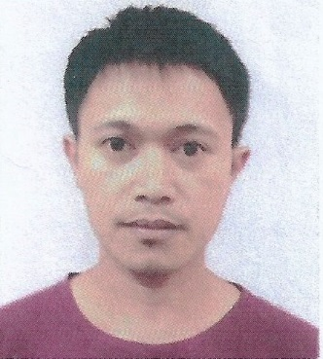
Jonathan
Email: jonathan-399572@2freemail.com
Mobile No: +971504753686

OBJECTIVES:

To obtain a position where I can use my educational knowledge and skills related to my educational attainment that will establish and enhance both my knowledge and skills and to make a positive contribution to the organization.

Working Experience:

2014 to Present Abu Dhabi-based Company
Pest Control Sub – Leader

- Responsibilities:
- Certified and experience in pest management, technology and treatment techniques.
- Certified in reading and understanding all product labels.
- Certified in Health and safety audits relationship to the environment.
- Experience and understanding and working with Arab culture and speak Arabic language.
- Educate customer about pest behavior and its relation to sanitation.
- Certified in applying IPM methodology in dealing with the customer concerns.
- Documented all pest management report under the ISO Standard.

Jan. - Dec. 2013 Global Measurement and Technologies Incorporated
Pump Technician
Libertad, Pasay city, Philippines
- Responsibilities:
- Maintenance for pump machinery, including inspecting pumps,
- Ensuring that pumps are always in working order.
- Troubleshooting, and other hands-on maintenance and repair work.
- Calibrating machine to correct measurement.

Jan. - Dec. 2012 FCR Business Machine Corporation
Programer - Technician
Binondo, Manila, Philippines
- Responsibilities:
- Installing and preparing new unit of cash register machine.
- Programing the files of the register machine.
- Troubleshooting, and other hands-on maintenance and repair work of the machine.

Training:

Certified International Franchise Training Program and
IPM Pest Management Procedures (UAE)
December 14, 2014

Thirty days Induction Training for Organization’s Operation and Activities; Pest Control, Animal Impounding and On-Call service (CWM169 – Lot 3) Requirements; and Basic Integrated Pest Management Procedures.
Certified International Franchise Training Program and
IPM Pest Management Procedures (UAE)
January 15, 2015

Skills and interest:

Troubleshooting and Repairing Electronic Divices
Computer literate (Basic Microsoft)

Personal Information:

Nationality : Filipino
Civil Status : Married
Sex : Male
Date of Birth : May 17, 1981
Language : English, Tagalog, Visaya and Basic Arabic

Educational Attainment:

College : Institute of Creative Computer Technology (ICCT)
V.V. Soliven, Cainta Rizal, Philippines
Micro System Computer Technician
1998 – 2001 (Undergraduate)

Secondary : Antipolo National High School (ANHS)
Bagong Nayon II, Antipolo, Rizal
1994 – 1998 (Graduate)

Primary : Bagong Nayon I Elementary School (BN1ES)
Bagong Nayon 1, Antipolo, Rizal
1987 – 1994 (Graduate)

Personal Qualities

I am reliable and honest person that can work well with people in order to finish my task that always gives my best when doing things and I can even work efficient while under pressure.

I hereby certify that above mention are true and correct in the best of my knowledge.
Thank you very much.

Jonathan
Signature

