Curriculum Vitae
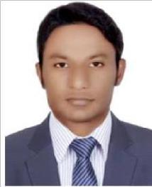

ALMAS

Email Id: almas-399590@2freemail.com

Mobile: +971504753686

CAREER OBJECTIVE

To be a part of organization with scope for a challenging career opportunity for learning with continuous improvement of skills, knowledge and experience with wider scope for growth.

Experience Summary

- 1.9 years of experience in the areas of backend profile.

- Verifying licenses of different commercial insurance by visiting its particular web sites and updating it company’s internal software.
- Billing of medical superbills of different disease with its respected amount.

ACADEMIC QUALIFICATIONS

- Graduation (B.C.A) from Indira Gandhi National Open University New Delhi, India.
- 10+2 from Uttar Pradesh Board, India.

PERSONAL QUALIFICATION

- Fundamental, MS Office.
- Internet Surfing, e-mail etc.
- Typing speed 45 w/m.

EMPLOYMENT

Company | Designation | From | To
Typing Services based | Archives Clerk | December 2018 | August 2020
In Dubai
EXL Service Pvt. Ltd | Back office executive | December 2016 | October 2017
Porteck India | Billing executive | October 2015 | November 2016
Infoservices Pvt. Ltd

1

PERSONAL DETAILS

Date Of Birth | : | 21 May 1990
Marital Status | : | Single
Language Known | : | English, Hindi, Urdu
Nationality | : | Indian

DECLARATION

I hereby confirm that the information provided by me is true to the best of my Knowledge and belief.

DATE:

PLACE:

ALMAS

2

