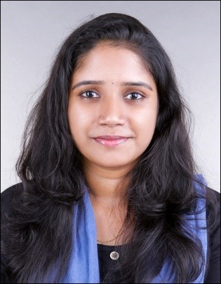 |  |  |  | vimi  CAREER OBJECTIVE  To become associated with a company where I can utilize my skills and  knowledge and to further develop these skills in a practical and fast paced environment while enhancing the company's productivity and reputation.
cONTACT  PHONE: +971504753686  EMAIL: vimi-399595@2freemail.com  Visa status : Visit visa  AREA OF INTEREST  Human Resource Management  Client Relationship Management  Business Development  Marketing & Advertising  Supply Chain Management  Logistic management  PERSONAL SKILLS  Communication & Interpersonal skills  Positive Team player and a Self Starter  Ability to multi task and meet deadlines  Critical Thinking & Analytical Skills  Time Management  Sound decision making  LANGUAGES  English, Malayalam, Tamil, Hindi  TECHNICAL SKILLS  MS Office Package  Social Media& browsing  PERSONAL FACTS  DOB: June 25, 1993  Marital Status: Single  Nationality: Indian  Hobbies: Travelling, Reading, Craft |  |  |  | experince  Currently working as HR EXECUTIVE in KERALA  - Designing hiring plan for Company of seasonal needs  - Maintain training attendance records  - Maintain confidentiality and security of employee records, files and information.  3 Months Experience as COORDINATOR at Astora international LLC MUSCAT OMAN  - Assisting in the recruitment and interview process  - Rearrange the working schedule of employees  - Mail Corresponding  - Manage employee database and document  1 Year experience as HR & ADMINTRATOR at Kart plus Ecom LLP KERALA  - Customer relationship  - Organizing, arranging, and coordinating meetings  - Mail Corresponding  - Maintaining a clean and enjoyable working environment  - Handling external and internal communication  - Upload files to the Social network’s sites such as Amazon, Myntra, Flipkart, Indiamart  EDUCATION  MBA (HUMAN RESOURCE AND OPERATIONS)  HAPPY VALLEY BUSINESS SCHOOL, Coimbatore  ANNA University, 2017-2019  69%  BA  FUNCTIONAL ENGLISH  Sreekrishna College Guruvayoor, Thrissur, Kerala  CALICUT University, 2014-2017  70%  PROJECT 2018 to 2019  MBA Operations  Topic: A Study on The Performance Analysis of a Logistic Firm GLOBEWAYS LOGISTICS Pvt.ltd, Cochin  SUMMER INTERNSHIP  MBA Human Resources  Topic: An Organizational Study at HOTEL POORAM INTERNATIONAL Thrissur, Kerala  PROJECT 2017 Feb  B A FUNCTIONAL ENGLISH  Topic: Translation Studies of a book called “KALPANDHAM” by M.T VASUDEVAN NAIR  ACHIEVEMENTS & AWARDS  - Certificate for best coordinator of CSR Activity [College level]  - Certificate for 1st price in western Music [college level]  ACTIVITIES  - Attended Industrial Visit Malaysia for 6 days as Part of Management Study.  - Appreciation for Volunteering “Dzone 2K16” National level intercollegiate fest conducted by Sreekrishna college Guruvayoor

