PERSONAL PROFILE
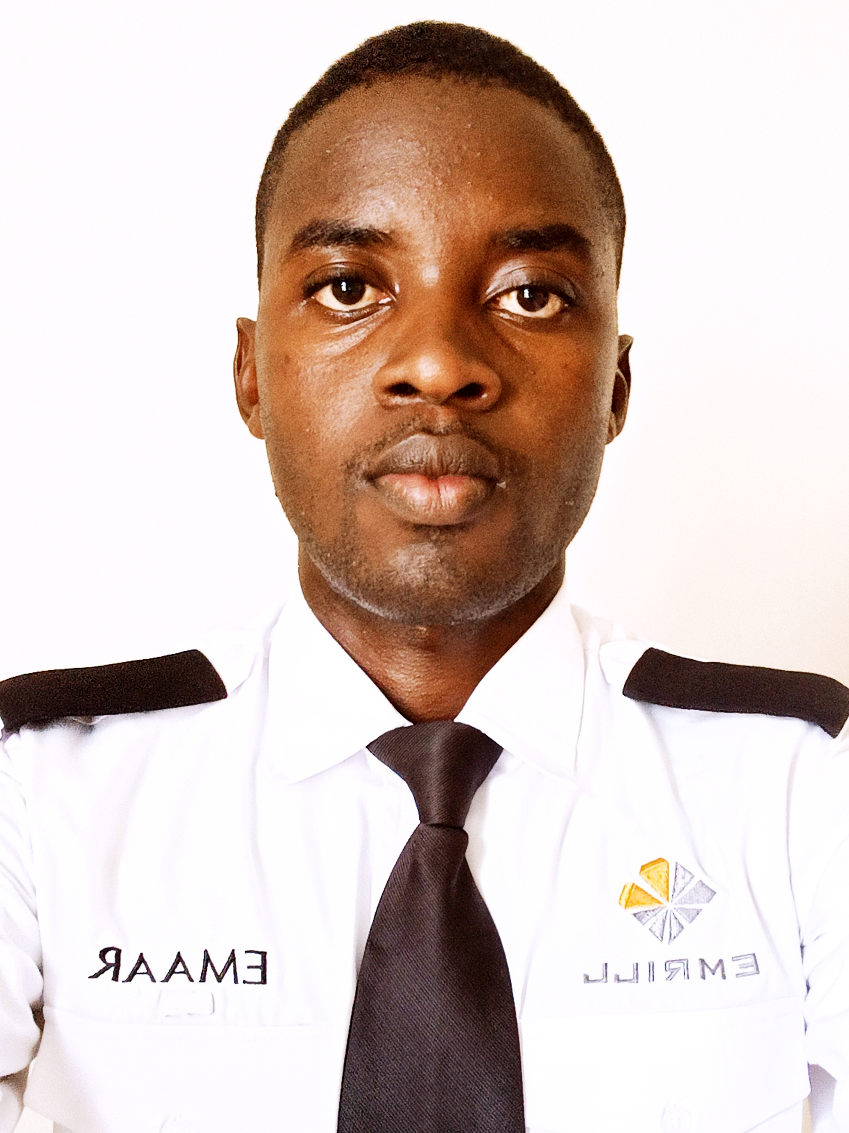
Name : SOLOMON
Address : UAE, DUBAI
Date of birth. . :18/07/1991
Marital Status : single
Email : Solomon-399601@2freemail.com
Mobile No : +971504753686
Visa Status : Resident Visa

Applying for : Security Guard

CAREER OBJECTIVE

To search for international experience through exposure, to develop my career and promote professionalism in product supply sector and contribute to development and advancement of the industry in line with my passion to serve.

PERSONAL ATTRIBUTES

- Self-motivated and capable of hardworking with minimum supervision coupled with learning new things and ideas.
- Good communication skills
- Efficient team player to enhance productivity.
- Excellent interpersonal skills.
- Computer literate.

WORK EXPERIENCE

01/03/2020.to 29/07/2020
POSITION: Security Guard

- Access control by checking for move in permit.
- Checking for move out permit
- Screening all contractors entering the premise.
- Checking all vehicles entering in & out the community.

EDUCATION BACKGROUND

Level of education : high school graduate.

INTERESTS, HOBBIES & PERSONAL ATTRIBUTES

- Exceptional interpersonal and organizational skills, Communication.
- Ability to work under pressure and handle multiple activities and projects concurrently.
- Team work player
- Maintain a professional appearance with a positive attitude and flexible

DECLARATION
I declare that the above information is correct to the best of my knowledge. Referees and academic papers are available upon request

