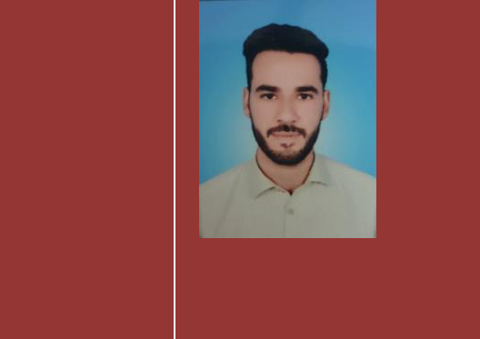

2020

Curriculum

Vitae

Bilal

Objective:

Experience sales, marketing, inventory & warehouse and customer Relationship management professional looking for suitable post to help boost my career by achieving organization goals and objective and target results.

United Arab |  |  | Personal Information:
Emirate Abu Dhabi
Mobile No: |  |  | Religion : | Islam
 |  |  | Gender : | Male
Nationality | : | Pakistani
Visa Status | : | Visit Visa
Date of Birth | : | 01-01-1994
Domicile | : | Swat

ACADEMIC QUALIFICATION:

Degree/Certificate Institute Session

Middle High School Mingora 2010

Experience :

- Raisa Tailoring Shop Sale officer

May 2013 to May 2017 (4 year)

- Managed warehouse inventories.
- Explored new customer in market.
- Managed existing customers and relationship management.

- Follow up customer orders and on time deliver
- Sales invoices
- Maintained proper inventory level for each product
- Effectively managed team for better outputs and results.

- Day Sun Tailoring Shop Casher

July 2017 to December 2019 ( 2 years)

- Operate register, and count money in cash drawers to ensure the amount is correct.

- Maintain thorough knowledge of store merchandise, and responsible for selling in store credit cards.

LANGUAGES:

ENGLISH: Good speaking listening & writing proficiency
Arabic: Good speaking listening & reading

Urdu : Hindi Native

Email: bilal-399614@2freemail.com
Mobile: 0504753686

