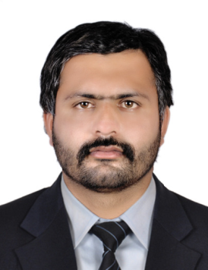
CURRICULUM VITAE
AHMED
Mobile- +971504753686

Email id: ahmed-399618@2freemail.com

Abu Dhabi & Dubai -UAE

POST APPLIED FOR FORKLI FT. SHOVEL , AN D EXCAVATOR OPERATOR
OBJECTIVE
Looking forward for an organization that offet‘s challenges, stimulating, learning environment to work and provide scope for individual & organization development, which offers attractive prospects for long term development and career growth.
GK1 PROF1L£i8
4 Good communication and interpersonal skills.
4 Hard working team member.
Have the ability to work for long hours.
4 Have the ability to work under pressure.
4 Good Listener & willing to learn more.
@GRBOMAL INFORMATION

4 Date of birth

4 Nationality Sex
4 Religion

4 Marital status
4 Language Known
EDUGATIONAL QUALIFICATION

4 High school
PASSPORT DETAILS

15-01-1996

Pakistani Male Muslim married
English, Arabic & Hindi

LI
4 | Date of lssue | 27-02-2019
4 | Date of Expiry | 16-02-2024
4 | Place of Issue | Pakistan
4 | License Details
4 | Date of Issue | 18-09-2017
4 | Date of Expiry | 18-09-2024
4 | Place of Issue | Dubai
4 | Permitted vehicle | Heavy Tractor

4 Worked as a Forklift & Shovel with Ali Rashid Transport, Dubai, UAE, for 02 years
4 orked as an Overhead Crane with Crown Paper Mill, Abu Dhabi, for 1 year.
4 Presently working as a Forklift Operator in a Paper Mill in Abu Dhabi, from August 2019 till date.
Declaration
I hereby declare that the above furnished infonnation is true and correct the best of my knowledge
and belief.
AHMED

