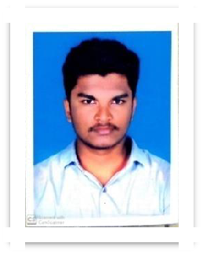

SUHAIL

Click here to buy CV Contact:
http://www.gulfjobseeker.com/employer/cvdatabaseservice.php

Whatsapp No: +971504753686

Email ID: suhail-399632@2freemail.com

Career Objective

An energetic and proactive professional with more than 3 years of experience in the areas of Logistics and Freight management. Seeking appropriate positions with reputed employers. Excellent in communication and Relationship management skills. Possess a flexible & detail oriented positive attitude.

Professional Experience

Profiled as Documentation Executive during thr tenure Dec 2018 to June 2020.

Skylink Freight Forwarders International Fgreight Forwarders.

Ernakulam Nov 2017 To Sep 2018.

One year experience in (international fgreight forwarders) One month internship in skylink freight forwarders.

Flipkart Apr 2017 to Oct 2017.

Six months experience in Flipkart warehouse in Coimbatore.

Academic Qualification

Merchant Navy Cource from Ocean Dream Marine Training Institute Maharashtra-2019.

Dipolma in logistics and retail management & (SHIPPING) Institute for printing technology and govt. Poly , Shornur NSDC Certified

Draughtsman Civil NSDC Certified – 2016 ICK Pvt ITI Kariyad. Higher Secondary - Board of Secondary Education Madhya Bharat Gwalior (2014 March).

SSLC – Kerala Board GHSS Pattambi (2011 March).

Declaration

- hereby declare that the above-mentioned information furnished by me is true and correct to to the best of my knowledge and belief.

PERSONAL PROFILE

DOB: 26.05.1996

Nationality : Indian

Visa Status: Visiting Visa

Marital Status: Single

I am Strong At Building Relationships, Communication, Research & Enthusiasm

I Believe In

Empathy,

Team Work &

Punctuality

Linguistics

English

Malayalam

Hindi &

Tamil

IT Skills

Photo shop & Auto Cad

Suhail

