C U R R I C U L A M V I T A E
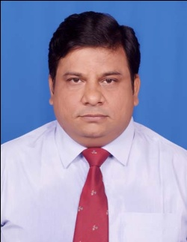
A S G H A R
+971504753686
Asghar-399647@2freemail.com
AN EXTREMELY MOTIVATED INDIVIDUAL WITH A NATURAL ABILITY TO SOLVE ACCOUNTING AND FINANCIAL PROBLEMS.

Key skills : Proficient in all major accounting platforms, Proficient in operating computer system as MS office, Accounting software system Tally, Internet, Excellent organisational skills with capacity to deal with multiple tasks at the same time, Ability to work on highly pressurise working environment, Top attention to detail and focus on making sure records and information systems are kept accurate and true.

Personal Info : Indian, Muslim, Married
Date of birth : 17/10/1969
Computer skills : MS office, Accounting software Tally, Internet
Qualification : B.COM (Bachelor in commerce), Accounts and Auditing
Computer Education : Diploma in information systems management (APTECH)
Languages Known : English, Hindi & Urdu
Joining Time : Ready to Join Immediately.

Working Experience:-
- Accountant – Worked with Khalid Bin Abdullah Al Mana Est. Doha, QATAR from June 2005 to October 2014.
Company Profile : Transport, Trading and contracting.

- Worked as an Accountant in an India-based Company from April 2016 to February, 2019.

Major Responsibilities in Accounts career: -
- Post and process of Journal entries of daily business transaction.
- Ledger. Trial Balance
- Cash Handling
- Salary preparation
- Preparation of Final settlement and Annual leave.
- Maintain record of postdated cheques of suppliers and customers.
- Reconcile of Supplier and Customer Payments.
- Prepared monthly invoices and update account receivable.
- Receiving and processing all invoices, expenses, forms, and request for payments.
- Reconcile of those customer invoice and details where payments are pending and delaying. Preparing Letter to them for payment, with attachment of reconcilable documents.
- Assist with preparation and coordination of the audit process.
- Assist Accounts manager and coordinate to external auditor at the time of final account, end of the year.
- Co-ordinate and assist Accounts Manager and external auditors and furnish them with required information and documents
- Other day to day work as requires by management.
- Any other duties and responsibilities as may be assigned by the management from time to time.
- Undertakes any other duties as required.
- Role reports into the Accounts Manager.

ASGHAR

