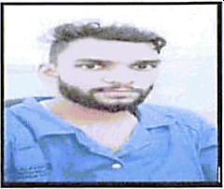

PERSONAL INF0RMATION

Date of Bírth
Gender Civil Status Nationality
Language known
: NOVEMBER 02, 1999
: Male
: SINGLE
: INDIAN
: HINDI & ENGLISH

£XPERI£NCIES

Abu Dhabi-based Company

HELPER

June 2019 to up to present

fi• Prepare and complete orders for delivery or pickup according to schedule (load, pack, wrap &

label)
fi• Communicate and cooperate with supervisors and coworkers fi• Complete all assigned tasks in a timely and efficient manner

ELMATICS ENGINEERING & PVT. LTD.(MUMBAI)
Mumbai, Índia

TECHNICIAN
fi• Follow all health and safety regulations when operating equipment fi• Clean and clear debris and hazardous materials
•t• Ensure all equipment and tools are cleaned and stored properly EDUCATIONAI. OUALIFICATION
DIPLOMA IN AIR CONDITIONING & REFRIGERATION
UJALA ELECTRONIC INSTITUTE- INDIA

OCTOBER 2018
2 YEARS

CONTACT DETAILS
Contact Email : manoj-399659@2freemail.com
Reference : Mr. Anup P Bhatia, Market Research HR & IT Consultant
Mobile No. : +971504973598

I hereby certify that the foregoing statements made by me are true and correct to the best of my knowledge.

MANOJ

