AKUA
Akua-399682@2freemail.com

+971504753686
ABU DHABI- UAE

CERTIFIED SALES PROFESSIONAL

OBJECTIVE

Certified sales professional with over 6 years of experience in retail seeking a position to utilize my acquired skills and knowledge in a company that offers employees professional growth and retentions
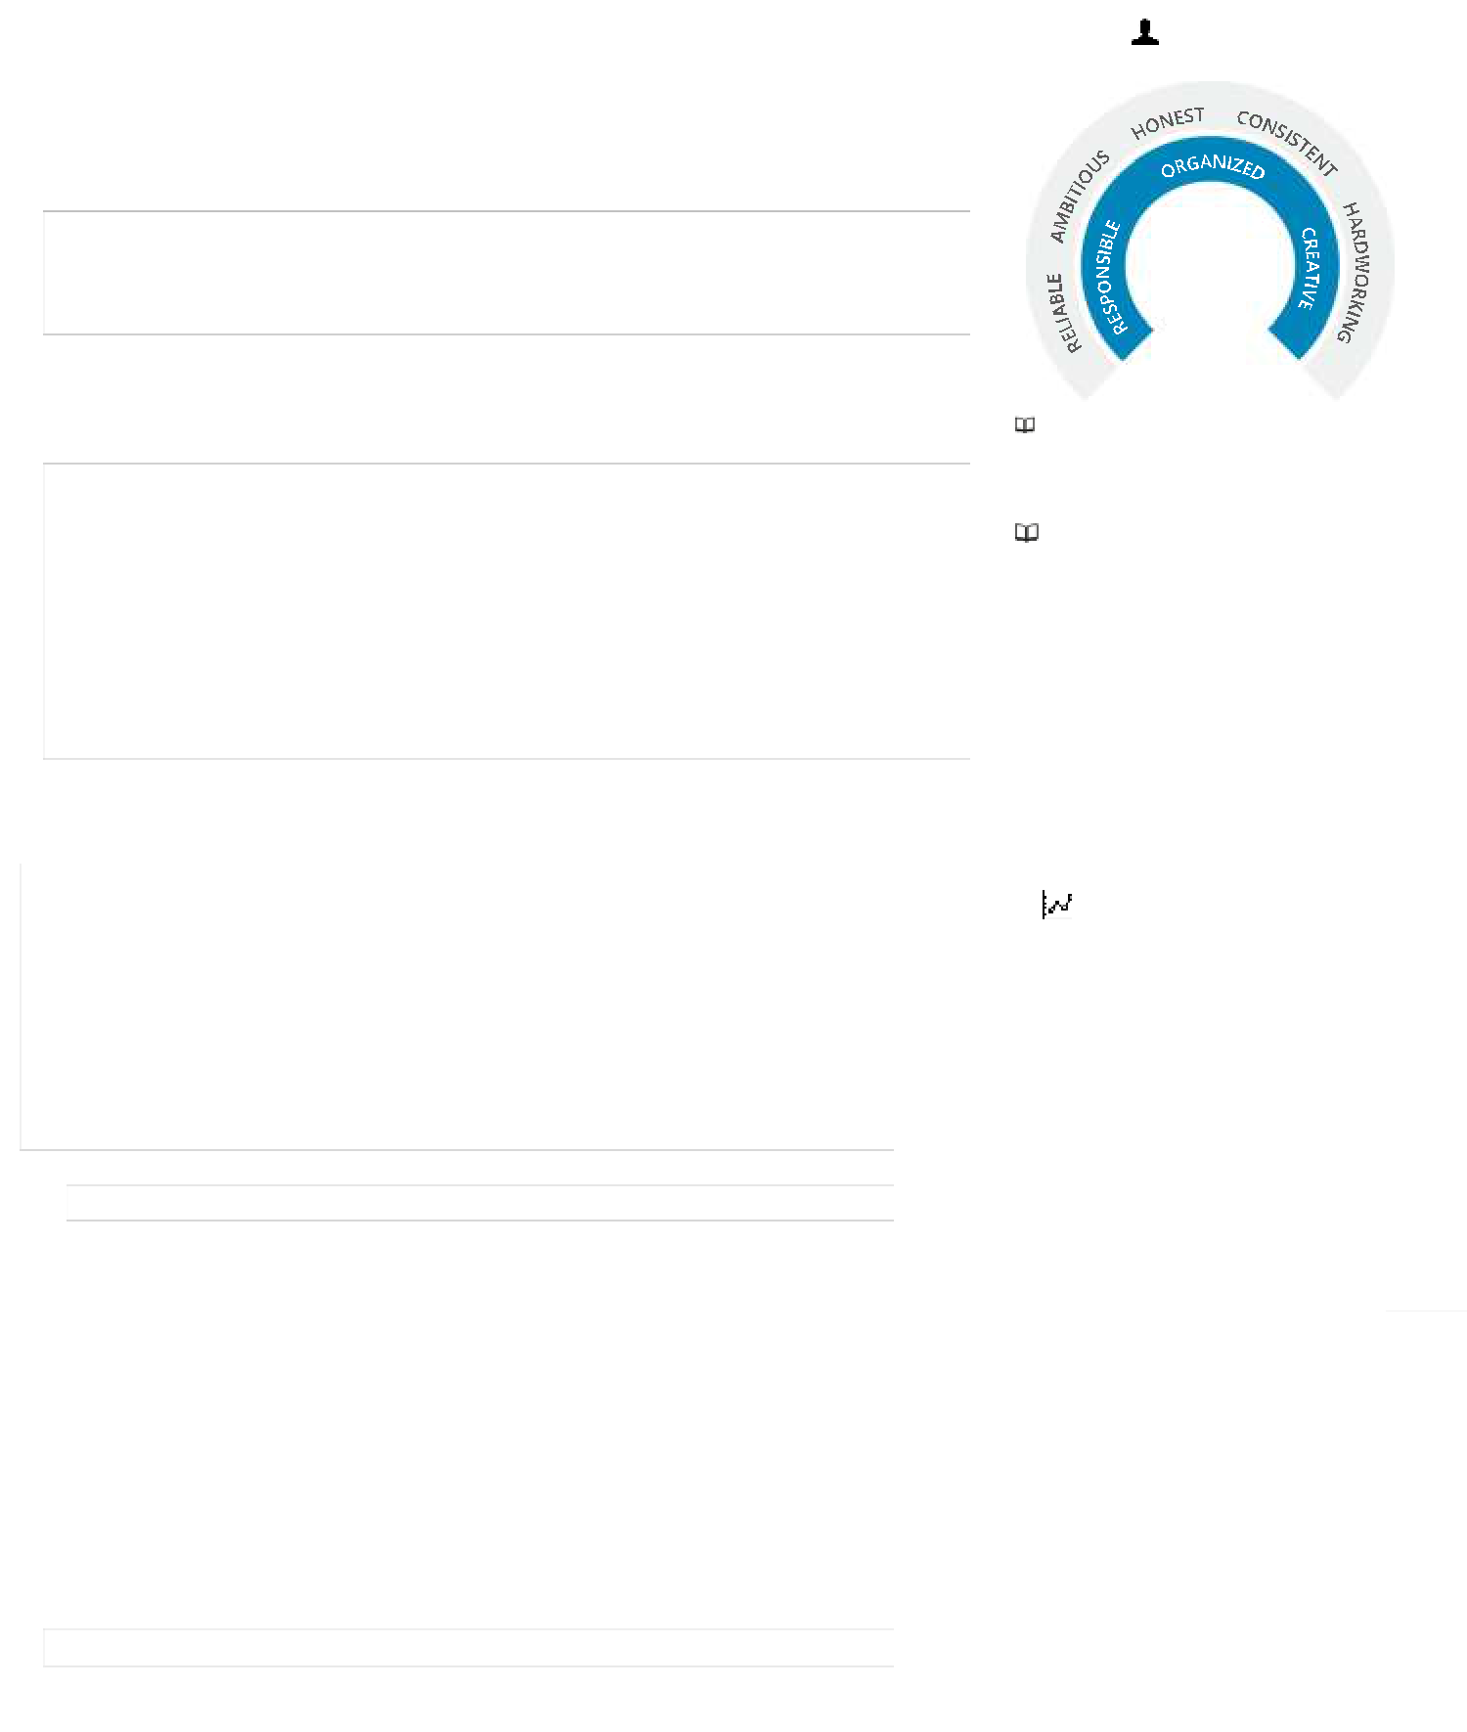

SENIOR SALES SUPERVISOR 2019-2020 | WHO AM I?
: Recognized Retail Brand in ABU DHABI
❖ Performed duties in department busy store including POS ,stocking,
merchandising, pricing
❖ Train New Employees on Sales and Visual Standards
❖ Greeting customers and assisting them with their choice of products

- Process Customer Transactions-picking up customers on the floor as stylist

- Team leader-Lead the team of sales associate on promotional campaign and on sales floor.

- Maintained up-to-date product knowledge and information on upcoming product releases.

HEADCASHIER-2019-2020
- Handle cash, credit or check transactions with customers

- Scan goods and collect payments

- Ensure pricing is correct

- Issue change, receipts, refunds, or tickets

- Redeem stamps and coupons

- Count money in cash drawers at the beginning and end of shifts to ensure that amounts are correct and that there is adequate change

- Make sales referrals, cross-sell products and introduce new ones

- Resolve customer complaints, guide them and provide relevant information

STORE IN CHARGE
LASENZA-LIWASTORES-ABU DHBAI-2016-2019

AKUA

EDUCATION

TSWANE UNIVERSITY OF
TECHNOLOGY – South Africa
- Economic Management Analysis

REGIONAL EDUCATIONAL INSTITUTE-UAE Management & Development Program-

MDP -UAE

CERTIFICATIONS
- Certified Bra specialist

- Certified Fragrance Specialist-

- Certified Beauty Accessories -

- Women clothing and fashions-Lasenza

Visual Merchandising-Lasenza

- Worked in line with the line manager on all updated stocks ,display & visualizing the store

- Maintains staff by recruiting, selecting, orienting, and training employees; developing personal growth opportunities.

- Accomplishes staff job results by coaching, counseling, and disciplining employees; planning, monitoring, and appraising job results; conducting training; implementing enforcing systems, policies, and procedures.

- Maintains safe and healthy work environment by establishing and enforcing organization standards; adhering to legal regulations.

HEADCASHIER LASENZA-LIWASTORES ABU DHABI
- Manage transactions with customers using cash registers

- Scan goods and ensure pricing is accurate

- Collect payments whether in cash or credit

- Issue receipts, refunds, change or tickets

- Redeem stamps and coupons

- Cross-sell products and introduce new ones

- Resolve customer complaints, guide them and provide relevant information
- Greet customers when entering or leaving the store

- Maintain clean and tidy checkout areas

- Track transactions on balance sheets and report any discrepancies

- Bag, box or gift-wrap packages

 | PROFESSIONAL SKILLS
Communication |  |  |  |  |  |  |  |  |  |  | 95
Organization
 |  |  |  |  |  |  |  |  |  |  |  |  |  |  | 95
Negotiation
 |  |  |  |  |  |  |  |  |  |  |  |  |  |  |  | 95
Problem Solving
 |  |  |  |  |  |  |  |  |  |  | 90
Multitasking |  |  |  |  |  |  |  |  |  |  |  |  |  |  |  | 95
Mobility
 |  |  |  |  |  |  |  |  |  |  |  |  |  | 90
Self Motivated
 |  |  |  |  |  |  |  |  |  |  |  |  |  |  |  | 100
Attracting
 |  |  |  |  |  |  |  |  |  |  |  | 100
Discrete |  |  |  |  |  |  |  |  |  |  |  |  | 80
- Achievements and Records

- Practical skills: I have strong negotiation skills which have secured a number of lucrative contracts for my previous employer

- Team management: I have led a team of sales and marketing executives in a promotional campaign that resulted in increased sales of 97K in a single day and the company exceeding its annual sales targets by 25%

- Sales success: I increased my territories client base by 30% year-on-year

- Awards/Consistency: I won Sales Person of the Year for two consecutive years having exceeded all quarterly sales targets by an average of 25% over a twenty-four month period

AKUA

Akua-399682@2freemail.com

+971504753686
Abu Dhabi, UAE

CERTIFIED SALES PROFESSIONAL

COVER LETTER

Dear Hiring Manager

Being relevant sales professional and maintaining consistency over 6 years is the most priority of every recruiter. My status as the store in charge, Sales Supervisor, Senior Sales Associate, Head cashier, customer service trainer holding certification in sales, bra, fragrance, visual merchandizing, beauty and accessories proves my professionalism and readiness to offer my best to your reputable company.

Having worked in South Africa, UAE and Ghana will always create a good atmosphere for me to deal with customers in a professional and competent manner.

Some key points that are relevant to this opportunity include:

- successful track record of providing and driving powerful sales

- achievement of sales growth over the years is overwhelming

- conversion of over 92% of customers to "repeat order" accounts

- effective introduction of new product lines and programs

- efficient implementation of operational planning to achieve aggressive budget goals

- proven history of recruiting and developing top performing sales teams across Abu Dhabi

I am positive that I can deliver the results you are looking for and I would welcome the opportunity to meet with you for an in- depth interview.

Regards,
Akua

