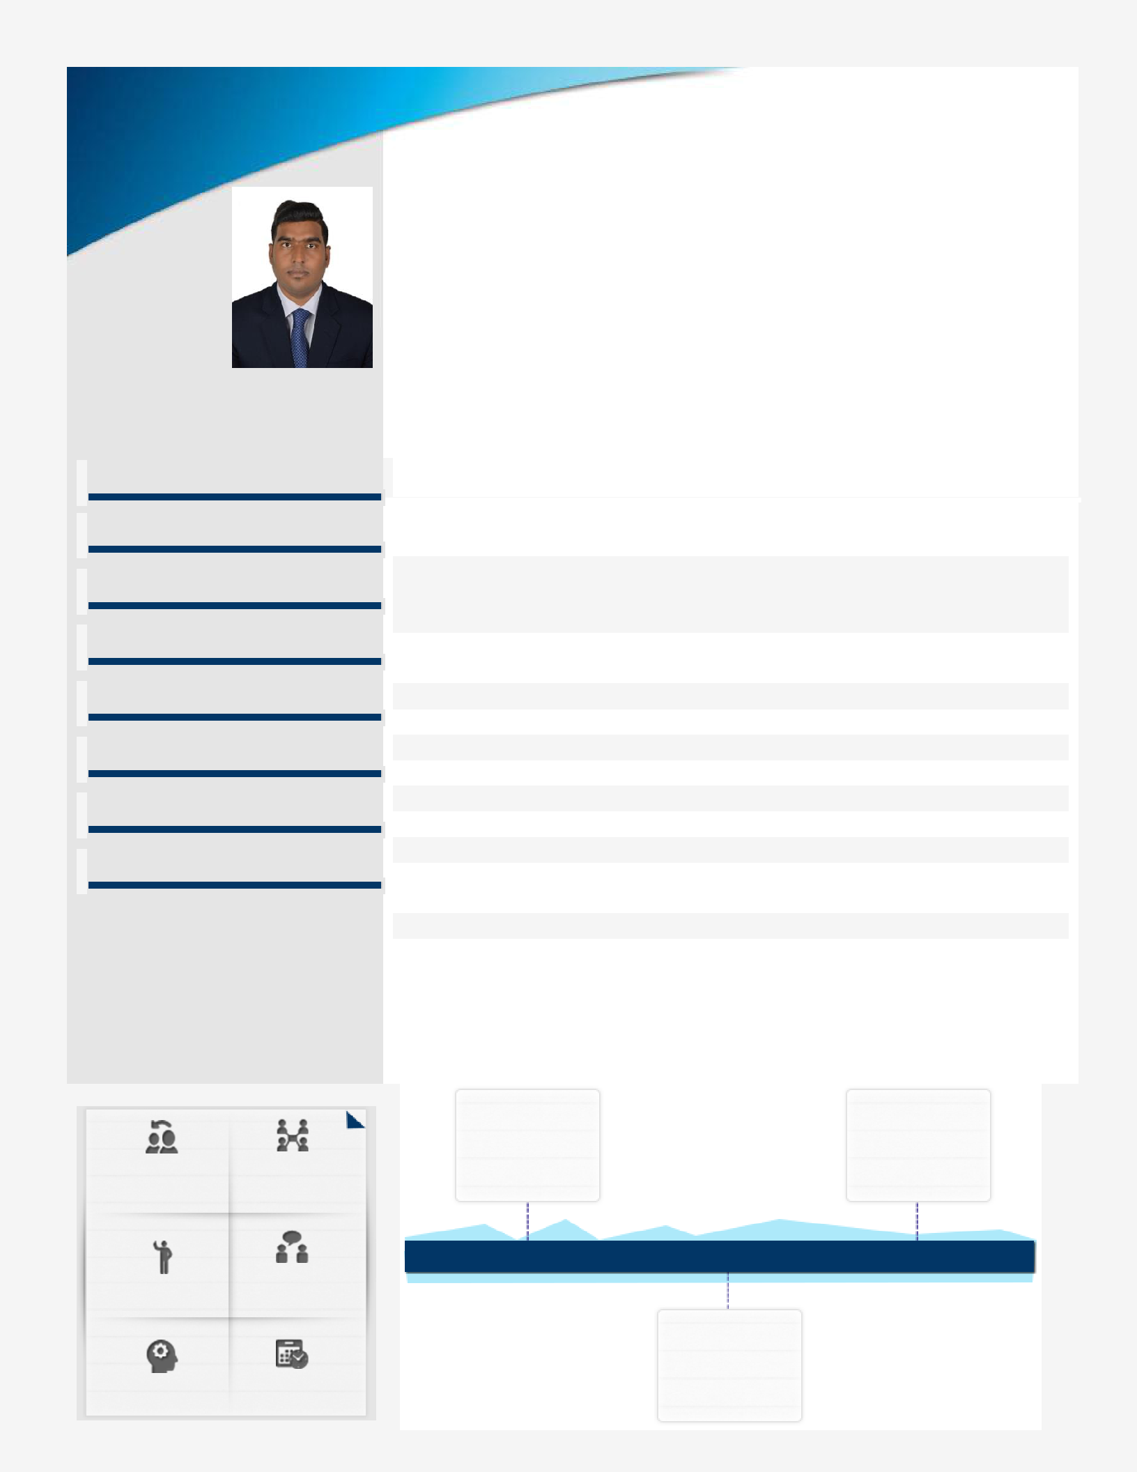
ASIF

Email ID: asif-399692@2freemail.com Contact No.: +971 50 4753686

Core Competencies

Civil Engineering Estimation/Costing
Reinforcement/Testing

Client Relationship Management

Project Execution

Quality Control & Assurance

Construction Operations

Reporting & Documentation

B. Tech. (Civil Engineering) professional with over 3 year of experience in Construction industry; targeting assignments in Civil Engineering with an organization of high repute, preferably in Construction industry Location Preference: UAE
Profile Summary

Last associated with Avantgarde Architects & Engineering, Fujairah site as a Civil Engineer (Standby/ Temporary posting), thereby engaged in conducting field inspection and drafting field reports and spearheading quantity take-off and cost estimation functions

- Comprehensive knowledge of managing projects, with a proven track record of executing Construction Projects

- Acquired knowledge of Construction Areas which includes Cost Estimation,

Quantity Surveying, Geo-Technical, Strength of Materials and many more

- Resourceful in on-site construction activities to ensure completion of project within the set parameters and delivering the project to the client on time

- Skilled in planning, executing and spearheading projects involving design coordination, value engineering, construction development, quality assurance/control, contract administration and resource planning

- Excellent relationship management, analytical and negotiation skills with skills in swiftly ramping up projects in coordination with clients, contractors, vendors and consultants

Soft Skills

Education Timeline

 |  |  | 10th from |  | B.Tech. (Civil
 |  |  | Rajasthan Board of |  | Engineering)
 |  |  | Secondary |  | from Rajasthan
Negotiation | Collaborator |  | Education (RBSE), |  | Technical
 |  |  | Rajasthan |  | University, Kota
 | Communicator |  | 2010 | 2013 | 2017
Team Player
 |  |  |  | 12th from
 |  |  |  | Rajasthan Board
 | Planner |  |  | of Secondary
Thinker |  |  |  | Education (RBSE),
 |  |  |  | Rajasthan

IT Skills

- Work Experience

Education

Personal Details

- AutoCAD 3D (Full)
- C, C++ and Microsoft Office tools

  - 24th Dec’19-10th Feb’20
Construction Company in Fujairah (UAE) as Civil Engineer

  - Nov’18-July’19
SAM Building Contracting, Dubai (UAE) as Civil Engineer

  - Apr’17-May’18
Five Star Construction Company, Mumbai as Junior Civil Engineer

Key Result Areas:

- Interfaced with the Process Engineers and engaged in following up, evaluating, presenting reports on trial materials according to designated schedules

- Performed the activities including field inspection, field reports, quantity take-off, cost estimating, steel reinforcement and concrete testing in compliance with material specifications

- Ensured suitable deployment and timely availability of manpower (designers, engineers & drafting)

- Conducted engineering drafting in AutoCAD, and worked in word processing, adobe, project scheduling, and spreadsheet

- Anchored on-site construction activities to ensure completion of project within the time & cost parameters

- B. Tech. (Civil Engineering) from Rajasthan Technical University, Kota in 2017
- 12th from Rajasthan Board of Secondary Education (RBSE), Rajasthan in 2013
- 10th from Rajasthan Board of Secondary Education (RBSE), Rajasthan in 2010

Date of Birth: 08th September 1995 || Languages Known: English, Hindi & Urdu

Address: Dubai, UAE || Nationality: Indian ||
Marital Status: Unmarried || No. of Dependents: 0 ||
Visa Status & Validity: Visit Visa , Valid till 20 December 2020|| Driving Licence: No

