ABDELKRIM
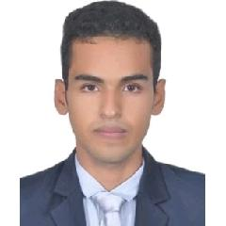

Email: abdelkrim-399708@2freemail.com

Whatsapp NO.: +971504753686

EXPERIENCE

Nov-2019 -
Oct-2020 |  | Content moderator
 |  | Review of content of social media platforms
 |  | Developing manners of handling the target job.
 |  | The use of multiple tasking skill and information analysis.
 |  | Expert of working in international work environment.
July-2019 - |  | Finashore
Nov-2019 |  | call center customer agent at Finashore on behalf ofONDA.
 |  | Mastering language skills in relation with customers.
 |  | Solving matters related to the service.
 |  | Adaptability and time management.

EDUCATION

2019 |  | Ibno zohr university
 |  | Bachelor degree of english linguistic
2018 |  | Ibno zohr university
 |  | undergraduate diploma of english studies
2014 |  | Baccalaureate in human Sciences.
Sept-2018 |  | Test of English for international communication (TOEIC).
March- |  | Youth Enhancement program certificate in Amideast laayoune.
2019. |  | Microsoft Oﬃce Specialist certificaties (Word,Excel,PowerPoint)
Sept-2018

SKILLS

Excellent customer service. Superior communication skills. Team building. Decision making. Orgnized. Polite .

LANGUAGE

English French Arabic Spanish

PERSONAL DETAILS

Date of Birth | : | 28/07/1995
Marital Status : |  | Single
Nationality | : | Moroccan

