CURRICULUM VITAE
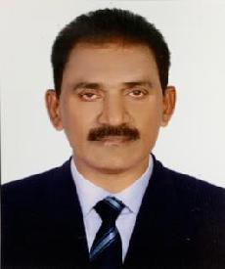

POST APPLIED FOR – MOTORCYCLE DRIVER

Email – saleem-399719@2freemail.com

Mobile no – 0504753686

OBJECTIVE:-

A suitable position with an organization where I can utilize the best of my skills and abilities that fit to my education skills and experience a place where an encouraged and permitted to be an active participant as well vital contribute on development of the company.

PERSONAL PROFILES:-

NAME |  | : | SALEEM
DATE OF BIRTH |  | : | 05/04/1963
Nationality |  | : | INDIAN
Religion |  | : | ISLAM
Marital status |  | : | Married
Languages Known |  | : | English , Arabic ,Hindi ,Urdu ,Telugu
PASSPORT DETAILS:-
Date Of Issue |  | : | 17/05/2013

Date of Expiry : 16/05/2023

Visa Status : Employment Visa

DRIVING LICENSE DETAILS

Driving License | : | Valid UAE D/L No 1
Date Of Issue | : | 31/10/2005
Date Of Expire | : | 31/10/2025
EDUCATIONAL QUALIFCATION

Graduate in Bachelor of Science (B.Sc Bzc)

PERSONAL SKILLS

1 Good Communication Skills

2 Dedication toward work

3 Prepared to work long hours on delivery days

DUTIES:

Delivering friendly and professional service to customers

Driving safely whilst obeying all traffic laws and regulations.

Making deliveries to our business premises and customers homes.

Maintain driving focused attitude at all times.

Comply with country rules and policies on health safety etc

EXPEREINCE :

1 ) Worked With Omrol Al Khayyam Restaurant Sharjah Deliver Driver for 2 Years

2 ) Worked with Resolution Graphics Center Sharjah as a messenger for 4 Years

3) Working in a Group of company Since 2014 Till Date

CONCLAUSION AND DECLARATION:

I hereby certify that the above mention statement is correct and true the best of my knowledge and belief.

SALEEM

