CURRICULUM VITAE
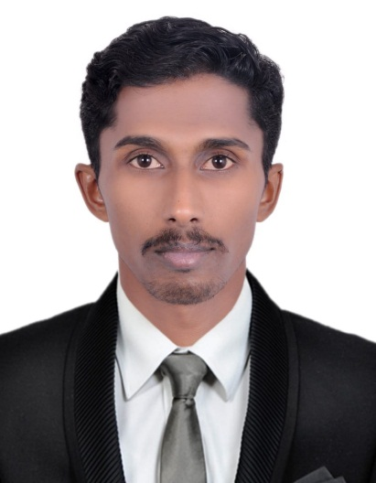
Personal Information
Name : Rasheed
Sex : Male
Nationality : India
Religion : Muslim
Marital Status : Married
Date of Birth : 06.04.1991
Mobile : +971 504753686
Visa Status : Working visa
E: mail : Rasheed-399723@2freemail.com

Position applied for senior civil technician with driving license.

Career Objective:

To work in an environment which offers good opportunity to contribute to the provision of services to others, share knowledge and skills; as well as achieving
the overall success of all stakeholders through teamwork.

Working Experience

Presently working as a coordinator in an Interior Decor company in Ajman.
Responsibility
- Driving with Work coordination (drawing checking and material delivery and stocks checking)
- Can make all types of gypsum false ceiling and partition with gypsum decoration (molding & cornice & flowers & Arch) grid ceilings. etc.
- Gypsum board joint finishing and Wall putty with painting.
- Before working with DAMAC Facility management team as a Civil multi technician (Handymen) for 2 year.
Responsibility
- Six months working with damac snagging team. Liaising with contractors to check on snag completion and updating status on application (SnagR)
- Recording of Water, Chilled water, and electrical Meter readings.
- Daily checking of building common areas for any issues and reporting to building management.
- Weekly two days security check list clearing and reporting to supervisor.
- Weekly works updates to building management on civil works completion.
- Have good hands on Glass rectification works, aluminum rectification works, tiling, masonry, carpentry, paint works, putty works and simple rectification of electrical and plumbing works.
- Sincere and dedicated to work.

- In INDIA more than SIX year working with Interior decoration & Engineering company as a site coordinator at Mishra and associates Calicut- Kerala ,India

- With Dubai Manual driving license number
- License issue date :17/03/2019
- Fire and safety training Dubai certificate
- Basic knowledge of computer (Excel, word, PowerPoint)

Educational Qualifications

- 10 th Class Passed
- Higher secondary Passed

Language capability

- English, Arabic, Hindi, Tamil, Malayalam

Passport Details
- Date of Issue : 19:05:2015
- Date of Expiry : 18:05:2025
- Place of Issue : Calicut

Declaration

I, hereby declare that the above shown statements are correct and true to the best of my knowledge and belief.

Sincerely:
Rasheed

