OBJECTIVE E

M
dynamic professional with over 10 years of experience in video, photo and W editing. i have worked on many clients with the most popular companies in L dubai & abu dhbai. we can help each others for growing business. I am O confident that my abilities and experience will allow me to perform
O
F
excellent work in your company.

+971 504753686
majid-399731@2freemail.com

MAJID

PHOTOGRAPHER
creative | ADVANCED SkILLS | Motivation | Confidence

Click here to buy CV Contact:
http://www.gulfjobseeker.com/employer/cvdatabaseservice.php

SkILLS
Basically i’m expert in all work which includes events, documentaries interviews, corporate, weddings, real estate video & photography also related production house field.

I have ability to understand in first meeting with my clients that which kind of work they wants to me and also have ability to know what my clients want to promote and they have massage to the world in the projects. I have experience to help them for adding more powerful contents in their stories

ADOBE PHOTOSHOP

ADOBE LIGHROOM

ADOBE premier pro

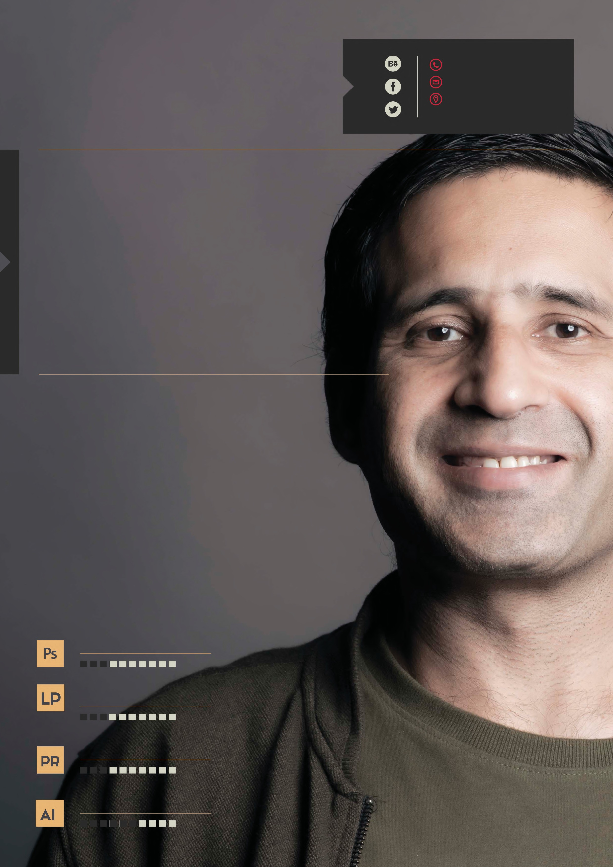
adobe illustrator
VIDEOGRAPHER
pakistani | 40 years | married
live in dubai

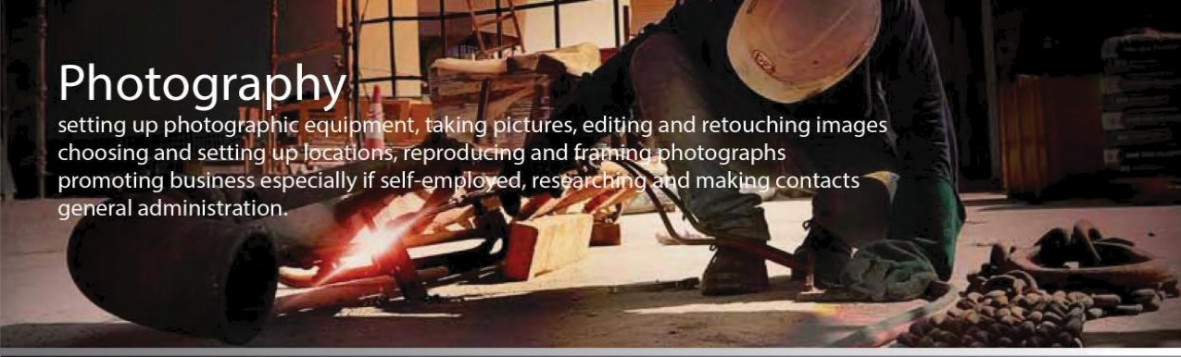
SeO
Social Media

Videography

Skilled cameras operator with Zhyan Crane a keen eye for detail and a critical mind creativity and

a passiondte interest in video the ability to listen to others and to work well as part of a team organisational

dncl time management skills Trained on multiple cameras and lenses of all sizes Able to edit with Premier or

G rase Vally Edius Knowledgeable about digital media and producing online content Able to work effectively
in both artificial and natural lighting the ability to work under pressure and to deadlines

Editing
Social media promo, commercials, corporate training videos, feature films

music videos, television programmes. Photography Editing, School Paorama

Software
Adobe Premier Pro. Adobe After Effects. Grass Valley EDIUS. Adobe Photoshop

Adobe Illustrator. ReSpeedr. ProDRENALIN

Increase the website’s ranking in the most important search engines and implement

online marketing strategies. • Conducted searches such as evaluating..

Social Media Marketing: Create/update and design Fan page and twitter profile for great user experience.

Work on variou s social networks like Linkedl n, YouTube, Flicker etc. For creating awareness and generate

sale perform viral marketing on Facebook, twitter and other social networks.

