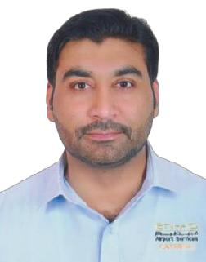
MR.MALIK

Mob: 050 4753686

APPLIED FOR: HEAVY VEHICLE DRIVER, SHOVEL OPERATOR

WORK EXPERIENCE

Presently employed in an Airport Catering Services in Abu Dhabi, U.A.E. as a Transport Operations Heavy duty Driver since 17-04-2016 till date.

(Assist Ramp support team and Team Leaders in Dispatch and other job functions as and when needed and requested by them)

Previously employed with ALSA ENGINEERING CONST CO L.L.C , Abu Dhabi, U.A.E. as a Heavy vehicle driver and heavy equipment operator .

Dec- 2012 to mar- 2016

Worked with AL FALAH READY MIX LLC, Abu Dhabi, U.A.E. as a Transport Operations

Heavy vehicle driver cum Shovel Operator.
DEC- 2008 to MAR-2012.

PERSONAL INFORMATION

Contact Tel. No. | : | 971.504753686
E-mail | : | Malik-399742@2freemail.com
Date of Birth | : | 14^{s-} 07- 1985.
Nationality | : | Pakistan.
Religion | : | Muslim.
Languages Known | : | Arabic, English, Urdu and Hindi.
Hobbies | : | Sporting, Surfing Internet, Outing.
Driving License | : | (Heavy Vehicle / Heavy Machinery)
 |  | Licensing Authority – Abu Dhabi, U.A.E.
 |  | Issue Date 30-06-2009 : Expiry 21-06-2024.

Total Driving Experience and Skills acquired in U.A.E. – 11 years

EDUCATIONAL QUALIFICATIONS

S. S. C. Examination : Government Boy’s High School TAXILA PAKISTAN

PERSONAL STRENGTH

Sincere , Honest, Punctual and Hard working.

DECLARATION

I hereby certify that the information provided is true to the best of my Knowledge.

I assure you Sir, If given an opportunity I will perform to the best of my ability and in the interest of the organization.

**************

