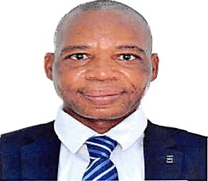
PROFILE SUMMARY
Click here to buy CV Contact:
http://www.gulfjobseeker.com/employer/cvdatabaseservice.php
Anthony
Anthony-399751@2freemail.com
Whatsapp No. +971 504753686
Location Dubai, United Arab Emirates

Goal oriented Accountant with over 20 years professional experience in the public sector. My key accounting and financial competencies include, but are not limited to, maintaining financial records, managing budgets, Bank Reconciliations, Maintenance of Suspense accounts and appraising the performance of Accounting Assistance. I am looking for a suitable position with an employer that has a supportive, growth- oriented environment that welcomes ideas on how to succeed and improve.

PERSONAL DETAILS
- Date of birth
- Nationality:
- Gender:
- Languages Spoken:

WORK EXPERIENCE

14 March1972 Zimbabwean Male
English

- Employer
Zimbabwe-based Company
PositionHeld Accountant From January 2015 to September 2020

Duties
  - Bankreconciliations
  - Posting Paymentvouchers
  - Respond to auditqueries
  - Preparation of annualreturns
  - Supervision of Accountingassistants
  - Preparation of quarterlyreports

  - Preparation of Appropriation Returns
  - PaymentRun
  - Preparation of annualbudget
  - Reconciliation and analysis of petty cashregister
  - Preparing financialstatements

- Employer
Ministry of Justice Legal and Parliamentary AffairsZimbabwe Positionheld Accounting Assistant
From April 2001 to December2014

- Employer
Zimbabwe Prison and CorrectionalService Positionheld Prison Officer From March 1991 to March2001

EDUCATION AND PROFESSIONAL QUALIFICATION

  - Masters of Commerce degree in Professional Accounting and Corporate Governance(GZU)
  - Bachelor of Science (Hons) Degree in Accountancy (Chinhoyi University) Degree
  - Institute of Chartered Secretaries and Administrators (GradICSAZ)- Degree
  - Diploma in Accountancy(SAAA)
  - Diploma in Business and Accounting Studies(IBAS)
  - National Intermediate Diploma in Business Studies(HEXCO).

SKILLS

Self Motivation, Highly organised, Ability to manage deadlines, Teamwork, Communication and interpersonal skills.

MEM BERSHIP

Institute of Chartered Secretaries and Administrators South Africa Association of Accountants

*References available on request

