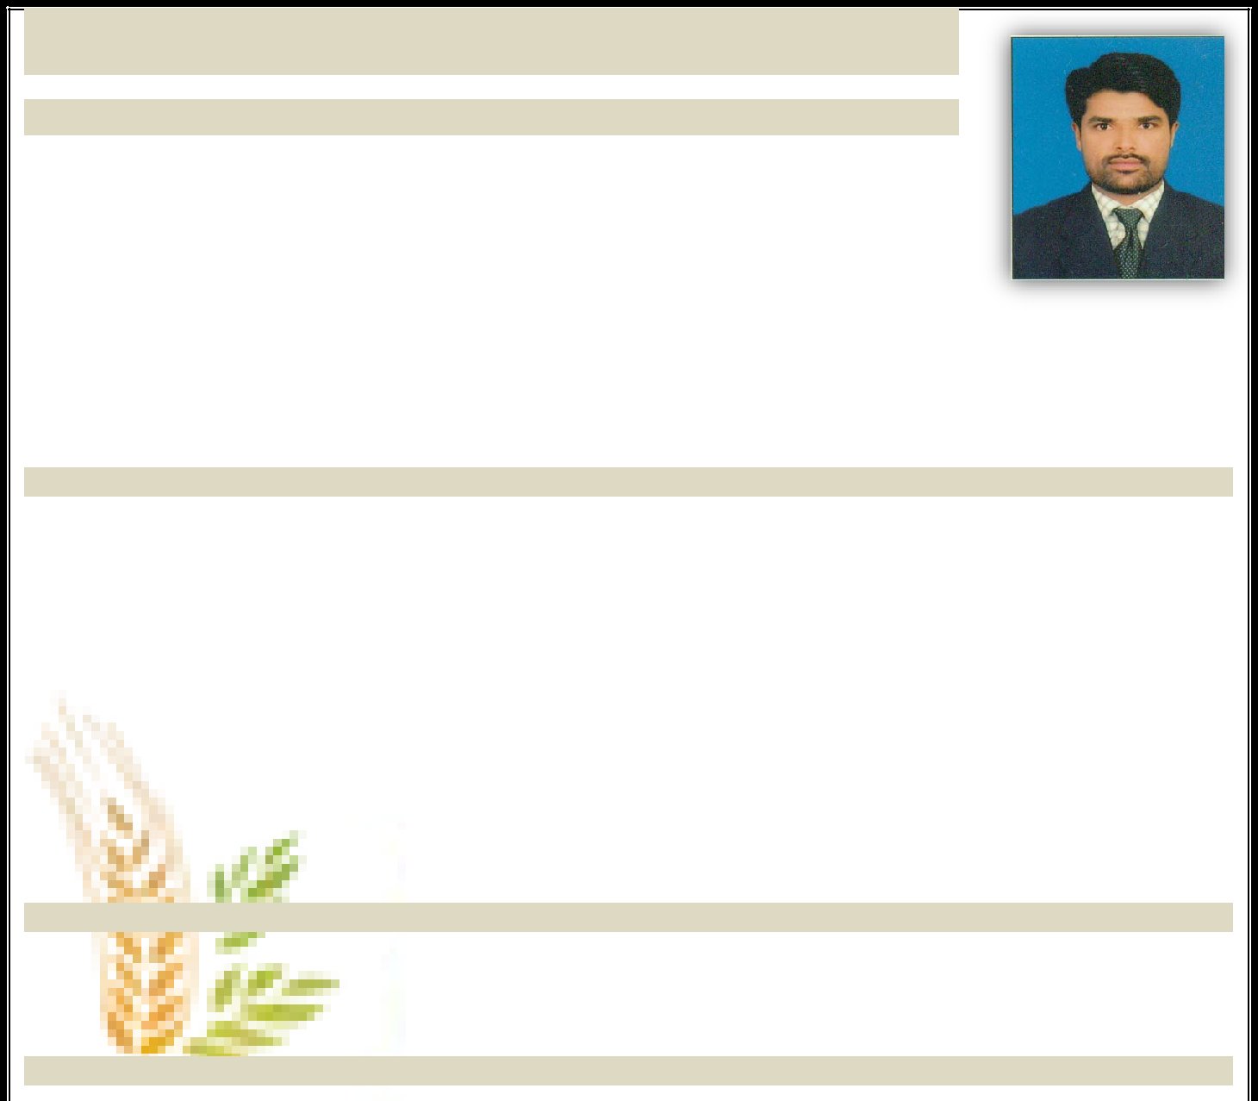
SHAHID

CAREER SUMMARY

I am D.A.E Mechanical having 05 years huge working experienced as Mechanical Technician in Fauji Fertilizer & 01 Year experience in (LOTTE CHEMICAL, ENGRO POLYMER, FFBL, NATIONAL REFINERY, PARCO KASBA GUJRAT, ENGRO FERTILIZER, PAKISTAN REFINERY & FAUJI FERTILIZER AS A MECHANICAL SUPERVISOR) & 02 years as a Mechanical Technician & Fitter in Descon Engineering (UAE) in Gasco, Adgas, Takreer Refinery, Brogue Polymer and

Fertile from 2006 to 2007, I also have experienced of working as Mechanical Fitter in different turnaround in Engro Chemicals, National Refinery, OMV Sawan, ENI Pakistan, Mari Gas field from 2003 to December 2005 and OMV Mehar Plant & Engro Polymer 08 Jan 2020 to 13 Feb 2020 I have also good knowledge about health & safety.

Plant Equipments Experience, Vessel, Colums, Boiler, Tank, Exchanger, Valves, Furnace etc. OBJECTIVES

Looking for rewarding and challenging career aim in field Mechanical Maintenance & all Types of Welding that can use my knowledge, skill and ability to make valuable contribution for company.

PERSIONAL INFORMATION
Click here to buy CV Contact: | http://www.gulfjobseeker.com/employer/cvdatabaseservice.php
Whatsapp Number | +971 - 504753686
Email | Shahid-399756@2freemail.com
Date of Birth | 26 -01-1983
Language | Urdu, English, Punjabi
Nationality | Pakistani

QUALIFICATION

Matriculation (Science) from Board of Secondary Education Sukkur.

03 years of Diploma of Associate Engineering in Mechanical Engineering from S.B.T.E Karachi and score 74% Marks.

PROFESSIONAL SKILL

Currently I am working as a Mechanical Tech

OMV PAKISTAN MEHAR GAS FIELD:

I am working as Mechanical Technician in Pakistan since 01st July 2016 to 30 May 2018

My responsibilities are:

Mechanical Maintenance of Heat exchanger and columns like HP Jetting, tube cleaning, tube repairing, hydro testing And process vessels overall inspection, repairs, and try’s replacement jobs.

Experience of Maintenance of all types of valves i.e. Gate, Globe, ball, deluge and butterfly etc.I also have experience Rectification of valve passing problem with lapping, welding of seat pitting and mechanical gland packing replacement, steam cleaning, greasing and replacement jobs repair.

New piping and structure fabrication and installation with pipe fitting and equipment are like as vessel, tank and column.

I also have experience of all types of welding.

ROTARY MAINTENANCE

During my professional career I also experience of P.D Compressor, all type of P.M and Maintenance Job and working on 12 cylinder cat engine & 6 and 12 cylinder Waukesha engine centrifugal and reciprocating pump maintenance, gland packing, bearing replacement, greasing, impeller and body repair and replacement Experience of maintenance of all types of steam traps, and GLG`s glass replacement.

TA-2007 at UTILITIES PLANT

De aerator maintenance (Trays replacement)

Cooling towers (overall Inspection, Replacement of damage fins and drift eliminators Water treatment area (Vessels Inspection, distributor cleaning)
Complete fabrication of strainers with shell and seal pot (Fabrication shop)
Modification in granlator, dryer (New GPRS Nozzles installed in granulator & new lifter and grizzly bears installed in dryer)

TA 2009 at Ammonia Plant

Changing the piping and knock out vessel of air compressor k 101-A (New piping with expansion bellows) New heat exchanger installed (A-302) at ammonia plant
Valves replacement & rectify hard to operate valve
All types of PSV`s and control valve remove and installed activity

FABRICATION SHOP & AMMONIA PLANT

New Heat exchanger AH-911 totally fabrication completed in target time and installed in Turnaround Experience of flanges replacement job of furnace lower ends
Hand on experience of Mechanical cleaning of Heat exchanger (E-402)

TA-2011 at FABRICATION SHOP

Fabrication of heat exchanger AH-932 (Bundle) for ammonia storage Good command on Vacuum test, SFT, Hydro test and installed

TA-2012

General area maintenance jobs
TA-2012 FFBL (Furnace and secondary reformer maintenance

BMR AMMONIA PLANT & BMR DAP PLANT

I have experience of working in modification and extension of DAP & Ammonia plant in FFBL

FABRICATION SHOP (FAUJI FERTILIZER)

Heat exchanger manufacturing in fabrication shop by the following standard (TEMA)
Experience of fabrication of 09 heat exchangers in FFBL WORKSHOP (l –tubes and U bundle)
Experience of working on HP jetting machine, hot tapping machine, sheet rolling machine and plasma gas cutter Fabrication of E-314 A / B
Working experience of fabrication of heat exchanger shell fabrication

SKILL IMPROVEMENT PROGRAM (FFBL)

Heat exchanger, pumps, safety skill programme, valves, steam traps, online leakage rectification andgasket.

SAFETY AWARNESS (HSE)

I have handsome safety awareness against personal safety as well as plant safety.

Awareness of safety topics like housekeeping, fire emergency handling, heavy ammonia leakage and first aid.

REFERENCE

Will be furnished upon demand.

