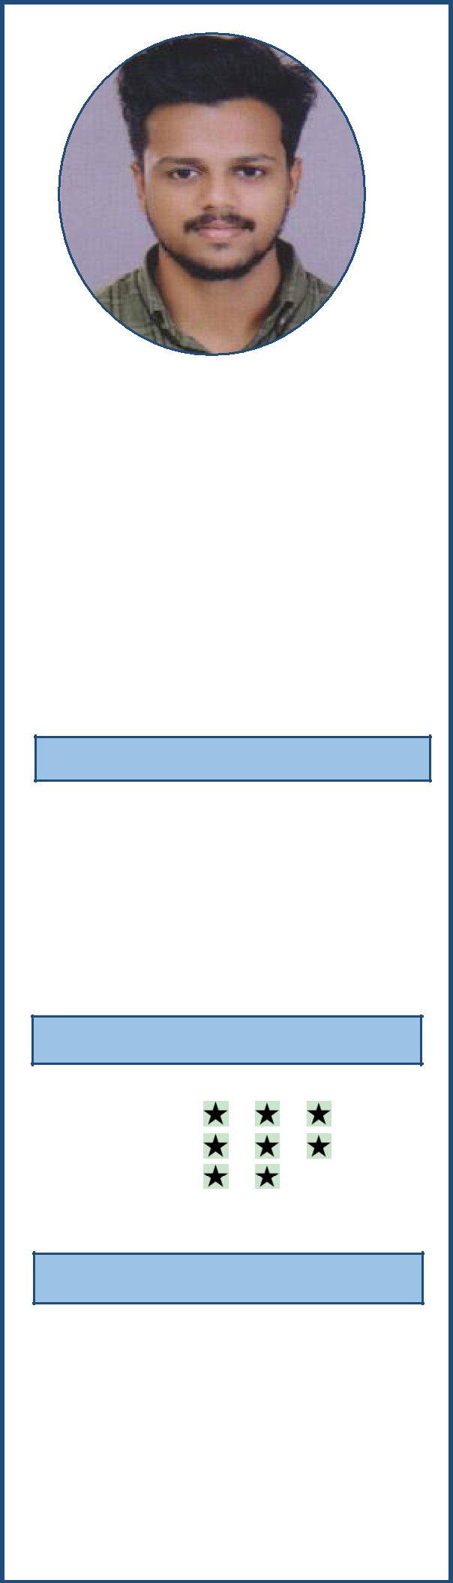

PRANAV N K

Nellikkunnummal House,

Valiyaparamba Post,

Koduvally,

Kozhikode, Kerala.

Pin : 673572

+ 91 8075785872
nkpranavtsy@gmail.com

PERSONAL PROFILE

Date of Birth | : 17-July-1996
Age | : | 23 Years
Sex | : Male
Blood Group | : O+
Nationality | : | Indian
Marital Status : |  | Unmarried

LANGUAGES

R W S

English

Malayalam

Hindi

HOBBIES

- Travelling

- Listening to music

- Playing

CAREER OBECTIVES

To be an important member of a team in an organization that would afford me Opportunities to develop innovate and contribute my very best by assimilating organizational strengths and ethos.

HIGHLIGHTS

An energetic, self-motivated and hardworking, able to provide an impressive customer Care service and work as part of a team. An effective communicator at all the levels within an organization, good problem solving and analytical skills, pc proficiency in MS office.

TECHNICAL SKILL

- Microsoft Office ( Word,Excel,Power point )

- Advanced Tally.ERP 9.0

- GST Accounting

- Gulf VAT Accounting

- Quick Books Accounting

- SAP Business one 8.8

- Sage 50 Accounting

- Tally ACE Certification from TIL

- HOTSOFT [Hotel Management Software]

- Inventory Clerk

- InvoiceNET Software

EDUCATIONAL QUALIFICATION

 | COURSE |  | INSTITUTION |  | BOARD/UNIVERSITY | YEAR OF
 |  |  |  |  |  | PASSING
 | Post Graduate
 | Diploma in |  | IPA |  | Global Accreditation | 2019
 | Indian & |  | Nadakkavu,Kozhikode |  | Board
 | Foreign
 | Accounting
 | M.Com(Master |  | LISSAH |  | University of Calicut | 2018
 | of Commerce) |  | College,Kaithapoyil
 | B.Com(Bachelor |  | Gadha College, |  | University of Calicut
 | of Commerce) |  | Poonoor |  |  | 2016
 |  |  | Govt.Higher |  | Kerala Education
 | Plus Two |  | Secondary School, |  | Board | 2013
 |  |  | Pannur
 |  |  | M J Higher Secondary |  | Kerala Education
 | SSLC |  | School, Elettil |  | Board | 2011

EXPERIENCE

- Completed an Intensive 6 Months training in Manual and Computerised Accounting from Management of IPA

- 9 Months Experience in Store cum Accounts from Arayal (Sharoy)

Luxury Resort Wayanad, Kerala.

- Presently Worked in TOPS FOOD Dry fruits Manufacturing Company Parappanpoyil, Calicut, Kerala.

Knowledge in ACCOUNTS

- Knowledge in accounts such as payments, receipts, recording of bank statements, inventory records, Data entry

- Prepation and maintance of Balance sheet.

- Auditing

- Knowledge in GST,journal entries

- Experience in Tally ERP.9

- Knowledge in Inventory Clerk

- Dat to day accounting

- Keep information confidential and secure them with random database backups

- Collect analiyze and summarize account information

- Computing taxes

- Maintain filles and documentation thoroughly and accurately,in accordance with company policy and accepted accounting practices
- Payroll Management

- MIS Reporting

Knowledge in STORE

- Review and verify orders submitted by requisitioning departments.

- Follow up with suppliers for efficient service and in case of late delivery of the materials ordered

- Ensure closure of purchase record after delivery of items.

- Ensure that the purchase order meets the criteria of quality, price, timeliness and reliability and also the standards of the company.

- Compare costs and evaluate the quality and suitability of supplies, materials and equipment

- Handle additional responsibilities as and when delegated by top management

- assist in purchase

PASSPORT DETAILS

Passport Number | T6868300
Date of issue | 22/07/2019
Date of expiry | 21/07/2029
Place of issue | Calicut, Kerala

DECLARATION

All the information provided by me in this resume is correct to my knowledge and I have not knowingly omitted any related information, which would have a bearing on my employment with you.

Place : PRANAV N K

Date :

