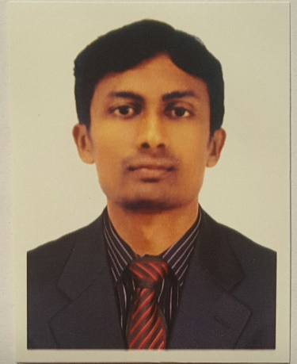 **CURRICULAM VITAE**

**MUTHAPPA**

**OBJECTIVES**

To secure a good position in my career that will enable me to use my interpersonal and communication skill to the optimum level.

**EDUCATIONAL GROWTH**

* B.A
* PUC
* SSLC

**COMPUTER SKILLS:**

* TALLY 9.0
* MS OFFICE

**STRENGTHS:**

* SELF LEARNING & HARD WORK
* LOVE INTERACTION WITH PEOPLE
* INNOVATIVE THINKING

**HOBBIES:**

* READING BOOKS & WATCHING TV
* PLAYING CRICKET, BADMINTON & FOOTBALL

**EXPERIENCE:**

1)WORKED ONE YEAR IN FEED SHIWROOM AS COMPUTER OPERATOR AND SALES EXECUTIVE. GONIKOPPAL, INDIA.

2)WORKED ONE YEAR IN CALL CENTER(BPO) AS VOICE PROCESS. BANGALORE, INDIA.

3)WORKED 6 MONTHS IN CALL CENTER(BPO) AS DATA ENTRY OPERATOR. BANGALORE, INDIA.

4)WORKED TWO YEAR IN MOHAN AND SONS HARDWARE BUILDING MATERIAL SHOWROOM AS SALES EXECUTIVE. AL SATWA, DUBAI, UAE.

5)WORKED THREE YEAR IN WESTZONE SUPERMARKET AS SALES EXECUTIVE. AL KHAIL GATE, DUBAI, UAE.

**PERSONAL DETAILS:**

NAME : MUTHAPPA.K.C

DATE OF BIRTH : 08/01/1991

MARITAL STATUS : UNMARRIED

SEX : MALE

NATIONALITY : INDIAN

RELIGION : HINDU

**LANGUAGES KNOWN:**

WRITE : KANNADA, ENGLISH, HINDI

SPEAK : KANNADA, ENGLISH, HINDI & MALAYAM

MOTHER TONGUE : KODAVA

**DECLARATION:**

I here by that the above mentioned particulars are true and correct to the best of my knowledge.

**PLACE: Yours faithfully**

**DATE: (MUTHAPPA )**

**Email Address**  : [muthappa.399942@2freemail.com](mailto:muthappa.399942@2freemail.com) / [muthappa.399942@gulfjobseeker.com](mailto:muthappa.399942@gulfjobseeker.com)

**Mobile Number** : 0504973598

**Reference** : Mr. Anup P Bhatia, HR Consultant, Gulfjobseeker.com

**YouTube Video CV**

<https://www.youtube.com/channel/UCdsv_v9Czkx2Dc8bW4Bt4wA>

**View My CV on Gulfjobseeker.com CV Database**

<http://www.gulfjobseeker.com/employer/cv_database_highlighted_cv_freetocontact.php>

**Chat with me Live on Zoom**

<https://zoom.us/j/4532401292?pwd=SUlYVEdSeEpGaWN6ZndUaGEzK0FjUT09>