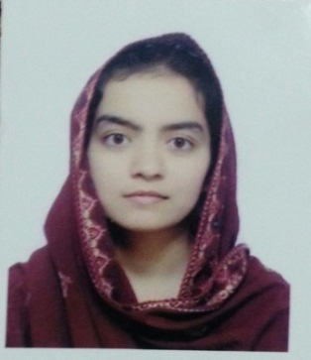
MEMOONA
MEMOONA.40406@2freemail.com

Career objective

To chart out a career in finance taking full advantage of my specialization in finance and to work with my full efficiency and integrity in long term association with any reputed organization.

Key Skills

Communication and teamwork
Able to communicate effectively in a professional business manner and as a member of a team. Strong written and verbal communication skills acquired through study and work.
Ability to meet deadlines and work under pressure
Working while studying a full-time bachelor degree has given me the time management skills to multitask and work under pressure. I am driven to meet deadlines while maintaining accuracy, and have never been late with an assignment.
Enthusiastic, hard-working and eager to learn
Reliable and trustworthy, with a strong work ethic and values. A high achiever; received university study grants every year from 2008 to 2010.
Technical skills
Strong technical proficiency in Microsoft Office 2010 (Excel, Access, Word, PowerPoint),

Language skills
Fluent in spoken and written English.

Experience

- 3 Month Experience Internship course from Bank Of Punjab,
Pakistan.

Education

Bachelor’s Degree – (B.Com) In Progress

Under Allama Iqbal Open University Islamabad, Pakistan
Intermediate - (FA) 2013
Under Board of Intermediate & Secondary Education Rawalpindi, Pakistan

Personal Detail

D.O.B Aug 10, 1992.
Visa Status Visit Visa (long term)
Nationality Pakistani

