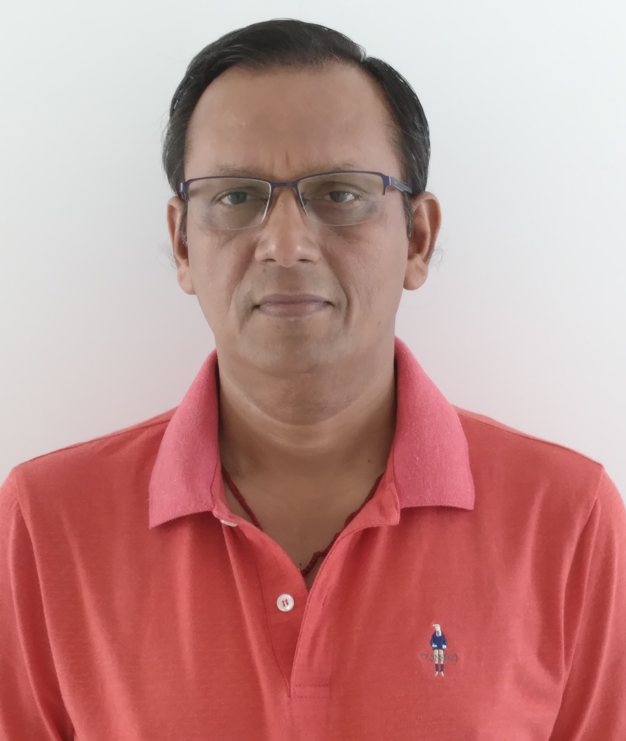
CHARTERED ACCOUNTANT

ANAND

Career Objective

To work in a challenging and dynamic environment and to keep value adding to the organization which I represent and serve, and to myself while concurrently upgrading my skills and knowledge. I would welcome an opportunity to consolidate and expand this quest for knowledge and in the process methods and solution resulting in improved, efficient and effective work process. My academic background, leadership skills, ability to work in a group and analytical skills will definitely be an additional advantage.

Educational Qualification

Associate Chartered Accountant (A.C.A.) – The Institute of Chartered Accountants of India.

Bachelor degree in Accounts, Finance and Economics from India

Practical Experience: 25 Years.

Present Engagement :

Project Head – Finance & Operations
Kongvong Aphivath (Cambodia) CO., Ltd
Phnom Penh, Cambodia
Oct 2016 onwards

Project :
- Established a New Company to enter into Reforestation project with Government of Cambodia.
- Identified, conducted due diligence and feasibility study to ascertain the area under reforestation.
- Interacted with relevant Ministries and Authorities related to reforestation investment.
- Prepared Business Plan and future projection of the Company for the relevant Ministries.
- Worked with the Government team to complete the field study and other related assessment of the project at Provincial Level.

Finance, Accounts & Statutory responsibilities:
- Responsible for accounting transactions and financial reports/statements are in accordance with accounting policies
- Ensure that required withholding taxes are recognized and paid on timely basis.
- Ensure that financial reporting supporting benefits and social security.
- Ensure that financial required financial reports supporting local registrations and other corporate filling requirements are complied with.
- Coordinate and support external and internal audit implementations
- Prepare monthly and annual Budgets,
- Prepare Financial Statements, Annual & monthly tax compliances, Company operations and other administrative aspects.

Chief Operation Officer
SK Plantation (Cambodia) Pte Ltd
Phnom Penh, Cambodia
Oct 2010 – Sep 2016

Project:
- Established a New Company to enter into business of Plantation.
- Identified, conducted due diligence and feasibility study to ascertain the area for Economic Land Concession.
- Interacted with relevant Ministries and Authorities related to Economic Land Concession and its Investment.
- Prepared Business Plan and future projection of the Company for the relevant Ministries.
- Worked with the Government team to complete the field study and other related assessment of the project at Provincial Level & Central Level.
- Successfully completed in getting Economic Land concession of more than 6500 Ha and Signing Contract with Ministry of Agriculture, Forestry & Fisheries for the Company.
- Completed Land registration for the Company working with Government officials.
- Completed Master Plan and get it approved by Ministry.
- Secure Land clearing approval to start the Plantation operation.
- Completed Timber Inventory over the area to finalize the Royalty payment to Forestry,

Finance, Accounts & Statutory responsibilities:
- Responsible for accounting transactions and financial reports/statements are in accordance with accounting policies
- Ensure that required withholding taxes are recognized and paid on timely basis.
- Ensure that financial reporting supporting benefits and social security.
- Ensure that financial required financial reports supporting local registrations and other corporate filling requirements are complied with.
- Coordinate and support external and internal audit implementations
- Prepare monthly and annual Budgets,
- Prepare Financial Statements, Annual & monthly tax compliances, Company operations and other administrative aspects.
- Responsible for Asset registers through annual counts and reconciliations.

Cash flow and Bank Account Management:
- Ensure that all bank accounts balances are properly reconciled.
- Ensure that sufficients funds are available to carry on the operations.

Director – Finance
PT Malaya Sawit Khatulistiwa
Jakarta, Indonesia
Jan 2008 – Sep 2010

- Worked as a representative of SK Plantation Pte Ltd, Singapore for the joint venture Investment in Indonesia.
- Worked with International lawyers to establish a Joint Venture with Indonesian Company in Palm oil Plantation business.
- Secure the Foreign Investment approval from BKPM, Republic of Indonesia for the joint venture.
- Interacted with the Banks for funding the Joint venture Investment in Palm Oil Plantation.
- Interacted with the Local team to secure more than 60,000 Ha of land under Palm Oil plantation and secured HAK GUNA USAHA(HGU).
- Carried responsibilities for Budgeting, Financial Statements, Annual & monthly tax compliances, Company operations and other administrative aspects on day-to-day basis.

Director – Finance & Operations
Adamjee Extractions Pvt Ltd
Colombo, Srilanka
Aug 2005 – Dec 2007

- Negotiating, Acquisition of existing local company for Foreign Direct investment in the business of Edible oil etc.
- Worked with Board of Investment of Srilanka in getting the Foreign Investment approved for setting up a Edible oil processing unit at Horana, Srilanka under Free Trade Agreement (FTA).
- Secured the Land for setting up the manufacturing Factory.
- Negotiated and finalized with the Plant suppliers, Building contractors, Materials suppliers, Electrical suppliers for the terms of contract.
- Getting approved the Term Loan of USD 2MN for the Project from State Bank of India, Colombo Srilanka by signing the Tripartite agreement between Company, Board of Investment of Srilanka and State Bank of India.
- Setting up the entire construction, manufacturing, operations and logistic team.
- Managed logistics, clearing and forwarding team, export documentation and other aspects for the export of Vanaspati from Srilanka to India port.
- Managed the entire import of Project material and import of Raw material for manufacturing of Edible oil from the custom port and Investment board.
- Getting approved the Duty free Import of all project materials from Inland revenue of Srilanka.
- Responsible for all function of the business to prepare Annual Business Plan / Budget, Assessment of monthly performance, analysis of variance from budget, identification of areas for corrective action and continuous improvement / sharpening of Management Accounting and Reporting System.
- Ensure proper closing of accounts within the time targets specified with due adherence to all statutory requirements and financial standards of the Company.
- Continuous monitoring inventory, receivables, and payables situation.
- Looking after Internal Audit & its control, Preparation of MIS reporting, Weekly Cash Flow statements, Monthly Projected Profit & Loss A/c,

Business Development Officer
Sing Global Oil Products Pte Ltd
Singapore/Indonesia
Oct 2003 – July 2005

- Responsible for looking new Investment opportunities in different countries for Palm Oil Plantation.
- Travel Indonesia to Build relationship with Palm Oil Manufacturers at Sumatera Medan, Jakarta, Kalimantan for trading of Palm oil to overseas buyers.

Accounts Manager
Utility Alloys Pvt Ltd,
Palakkad, Kerala
India

- In charge of Plant & Corporate Accounting, Finalization of accounts, dealing with auditors, Excise & Sales tax matters such as filing of monthly RT-12 return , maintenance of RGI register, issuing of Form C &F, liaison with bankers, Excise & Sales tax department officers, Annual assessment of sales tax & dealing with excise audit.

Accounts Manager
Sinhal Classes Pvt Ltd
Andheri, Mumbai
India

- In charge of branch accounting, Head office accounts up to finalization, dealing with auditors, lessoning with bankers, Taxation matters such as filing of TDS Returns, Computation of Income of Individuals & Company, their annual assessment, Company Law matters such as filing of Annual Return, maintenance of Fixed Asset Register, Minutes of Board & AGM . Monthly Return of Employees P.F & P.T., other office administration work, .Handled Block Assessment (Income Tax Assessment) of Individual & Company.

C.A Articleship
Bhuwania & Agarwal Associates (Chartered Accountants)
503/505, J.S.Road, 1st Floor, Chira Bazar – Mumbai – 2.

- The firm where I have done my articleship provides extensive training and grooms us to shoulder responsibilities right from the start of the articleship period after preliminary short induction program. I have participated in both statutory and tax audit. This has widened my perspective, ability to comprehend and appreciated the importance of keeping a macro picture in view while devising solution. The interaction with various management personnel during my work provided me an opportunity to build upon my communication skill and understand the work culture of corporates.

Personal Details
Nationality : Indian
Date of Birth : 1st June, 1972, Married
Email : anand-403613@2freemail.com
Computer Literacy : Working Knowledge of MS Office & Windows.
Reference : Mr. Anup P Bhatia, HR Consultant, GulfJobSeeker.com



