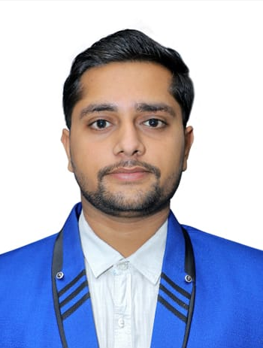
DEVRAJ CHOUDHARY
Accountant
devrajcpro@gmail.com
+91 9974 77 4244 (What’s-App)
Surat, Gujarat – 395010

- Career Objectives
To pursue a career with a progressive organization having a global vision that encourages creativity and offers an opportunity where I can contribute through my skills with sincerity & discipline to achieve the organizational goal & emerge as a better professional & human being in field of Accounts & Finance.

- Skills

- A Team Player.
- Energetic & highly motivated.
- Familiar with various accounting software.
- MS Office, TallyERP 9, ClearTax, Genius.
- Good analytical & problem-solving approach.
- Good knowledge of GST.
- General business knowledge.
- Effective communication.
- Prioritizing important wrok.

- Experiences

CA Rajesh Bhauwala & Co. – Surat. (Mar 2019- Jan 2022)
Responsibilities as an accountant.
- Filing & Finalizing GSTR 3B and GSTR 1.
- Preparation and filing of Income Tax & TCS Returns.
- Assisting in handling GST Audits, Tax audits and Statutory Audits.
- Responsible for finalization of books for audit.
- Checking smooth processing of bookkeeping, file & documents.
- Monitoring Financial Transactions & taking Necessary decisions.

Diamond King (Feb 2022-Continuing)
Responsibilities as an accountant.
- Preparing and Processing payments of banks.
- Maintain stock register.
- Doing various reconciliations related to TDS & GST.
- Calculating & Releasing Salary of employees.
- Verify Day to Day accounting entries done by Junior Accountants.
- Ensure all business transactions are recorded properly.
- Other accounting assignments as received time to time.

- Academic Background.
B.COM | VNSGU – 2022 | 65%
12th | GSHSEB - 2019 | 76%

- Languages Known.
- Hindi
- English
- Gujarati
- Marwadi

- Additional Experience.
- Knowledge of cash handling
- E-commerce
- Public Relationship

- Strengths.
- Can perform under pressure and stressful situation.
- Business development
- Attention to detail.
- Effective communication.
- Time management.
- Always ready to learn.

I hereby solemnly confirm that the details and information given above are complete and true to the best of my knowledge.

Name: - Devraj Choudhary Date & Place: - 19/08/2022 Surat

