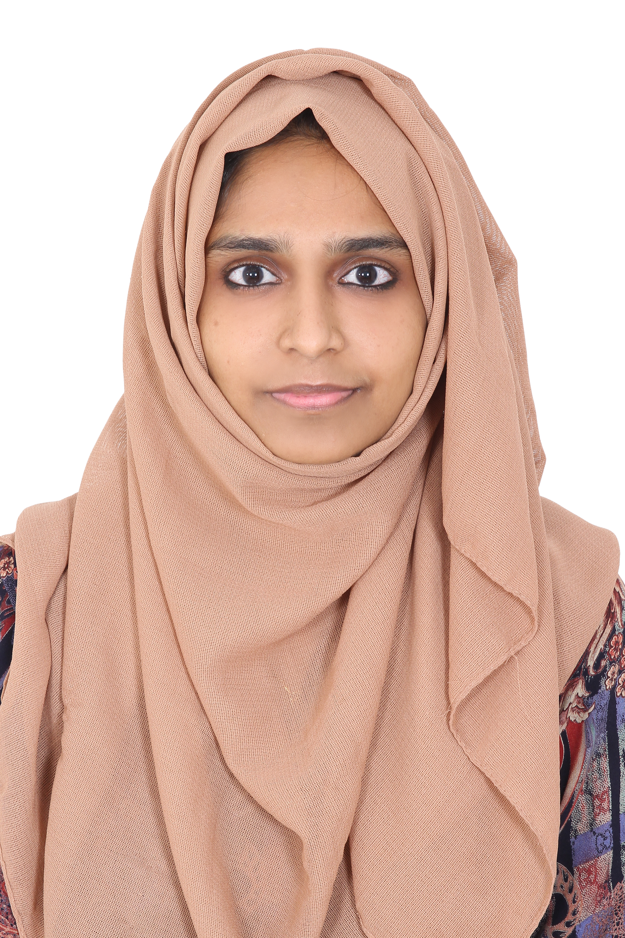

Dr. Amina
GP DENTIST (DHA / MOH)
amina-404241@2freemail.com

Objective
Ambitious qualified GP Dentist with excellent organizational and interpersonal skills. Keep securing a position with a dynamic and progressive dental practice. Ideal candidate for position requiring drive, initiative, responsibility, and challenge.

Personal Summary
A confident communicator who can relate well to dental patients. A confident healthcare professional who is looking for General Dentist opportunity to work with a forward thinking and highly regarded dental organization.

AREAS OF EXPERTISE
⬥ RCT  Crown cutting  Esthetic restorations  Simple orthodontic corrective procedures (removable orthodontic therapy  Assisted Senior Doctors in treatment procedures like Implant Placement, Apicectomy, complicated Tran’s alveolar extractions  Comprehensive course in COMPOSITES and ROTARY ENDODONTICS

CAREER HISTORY (Professional Experience 4 Years)

Jun 2020 – Apr 2021 General Dentist | Dental Wellness Clinic. Kerala, India
Nov 2016 – Oct 2019

Key Deliverables:

- Handling routine appointments and check-ups
- Prepare dental case file such as history taking, clinical examination, evolution of general medical record, recognition and diagnosis of pathological conditions, recording current dental status by using digital x-ray machines, suggest the best treatment plan and explain about the various treatment options and procedures to the patients.
- Dealing with emergency cases like relieving a patient’s pain.
- Performing treatments such as fillings and dental hygiene services, impression taking.
- Performing RCT, Crown cutting, Esthetic restorations.
- Filling cavities, examining x rays, repairing fractured teeth.
- Perform simple extractions.
- Simple orthodontic corrective procedures (removable orthodontic therapy).
- Assisted Senior Doctors in treatment procedures like Implant Placement, Apicectomy, complicated Tran’s alveolar extractions.
- Reassuring anxious patients and clearly explaining procedures to them
- Updating a patient’s medical record

Nov 2014 – Nov 2015 - Rotatory Internship

Key Deliverables:

- Providing professional dental service and care to patients.
- Examining a patients teeth and diagnosing their dental conditions
- Dealing with routine appointments and checkups, taking impressions.
- Dealing with emergency cases like relieving a patient’s pain.
- Procedures like root canal treatment and aesthetic buildup of teeth.
- Filling cavities, examining x rays, repairing fractured teeth
- Performing corrective surgery to extract teeth and replacing missing teeth
- Diagnosing and treating conditions such as decaying teeth and gum diseases
- Reassuring anxious patients and clearly explaining procedures to them
- Involved in dental examination and treatments such as fillings and dental hygiene services.

ADDITIONAL COURSES DONE
- Certified course in Porcelain Veneer, Anterior Composites, Rubber Dam Isolation (AESTHETIC MELANGE) conducted in Dubai – UAE (Feb – 2022)
- Comprehensive course in COMPOSITES
- Comprehensive course in ROTARY ENDODONTICS

EDUCATION
Bachelor of Dental Surgery (BDS) - Mahatma Gandhi University (June 2008 - May 2014)
Higher Secondary Education – Science (March 2006 – April 2008)

LANGUAGES KNOWN
- English
- Arabic
- Hindi
- Malayalam

PERSONAL DETAILS

Nationality : Indian
Date of Birth : 03/07/1990
Marital Status : Married
Visa Status : Husband Visa

