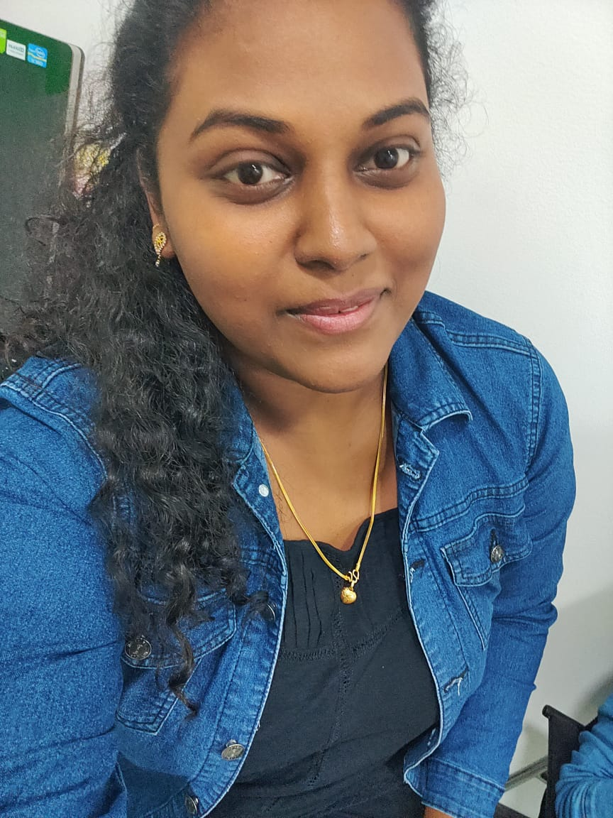
Aarty (B.A)

Admin / Customer Service / Sales Coordinator
Aarty-404777@arabianjobseeker.com +971504753686

CAREER OBJECTIVE

A challenging Career which offers an opportunity to apply my skills knowledge with continuous learning and growth.

SKILLS

Time management

Precise thinker

Pressure handler


EXPERIENCE

Dec-2020 - Dec-2021 Front Oﬃce Executive Hotel Lance international

Handling the guest and fulfill their necessities using the application called PUREAUTOMATE. Worked as a customer relationship executive, dealing with their checkin and checkout and more

Feb-2022 - Aug-2022 Assistant manager

Ammas Pastries Private Limited, India

Working with the company's application( RISTA) to run a smooth operation. Constantly training the staff regarding the FSSAI & GMP according to Indian standards. Inventory management and addressing the customer needs and also their queries.

EDUCATION


Degree/Course Institute/College University/Board



Percentage/ |  | Year of Passing
CGPA |  | Year of Passing

BA English


12th


10th

Pioneer Kumaraswamy College

Duthie higher

secondary school

Seventh day higher secondary school

Manomaniyam sudarnar University

Tamilnadu state

board

Matriculation

board

64% % |  | 2019
54% % |  | 2016
66% % |  | 2014

 | PERSONAL DETAILS
Nationality | Indian
Date of Birth | 27/11/1998
Marital Status | Single
Visa Status | Visit Visa
Languages Known | English, Tamil and Malayalam
Computer Skills | MS Office, ERP IT Skills

To arrange interview please contact us.


