

Email: [nabin-405021@2freemail.com](mailto:nabin-405021@2freemail.com) / Mob: +971504753686



1y ear - Kumar Raising

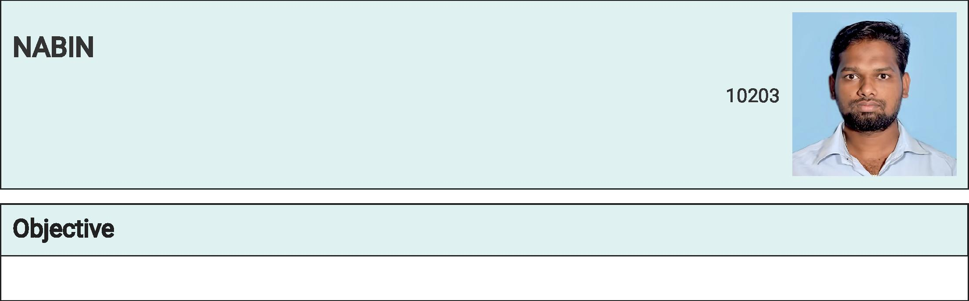

Seeking Employment With A Company Where Can Use My Talents And Skill T o Grow The Company .

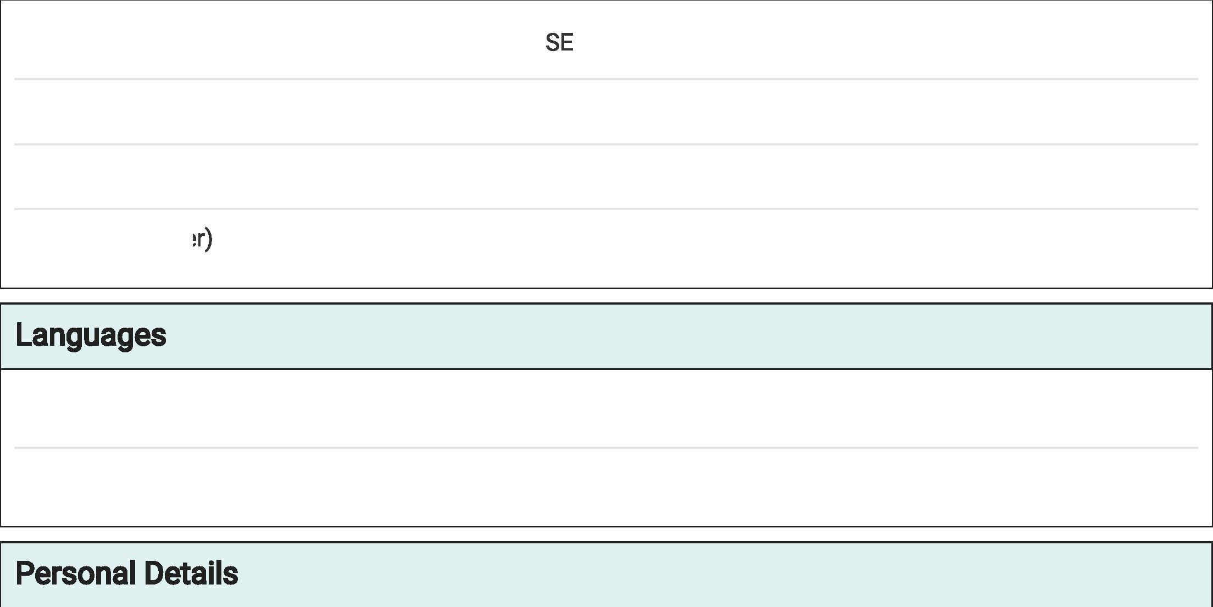

COMPUTER KNOWLEDGE AND COMPUTER COURSE

DCA-MS OFFICE ( Words, Excel, Power Point)

TALLY

TAMIL

ENGLISH



6 months - Thangal Mills Erode

|  |  |  |  |
| --- | --- | --- | --- |
|  | | | |
|  |  |  |  |
| B. Sc., B. Ed., | TAMILNADU TEACHERS EDUCATION UNIVERSITY | 78% | 0**2**1 |
| HSC | GOVERNMENT HIGHER SECOND ARY SCHOOL KA TTIMEDU | 76% | 7021 |
| SSLC | GOVERNMENT HIGHER SECOND ARY SCHOOL KA TTIMEDU | 84% | 2015 |



DRIVING (4weeler)

|  |  |  |
| --- | --- | --- |
| Date of Birth | 30 Nov 2000 |  |
| Marital Status | Single |  |
| Nationality | Indian |  |
| Religion | Islam |  |
| Gender | Male |  |