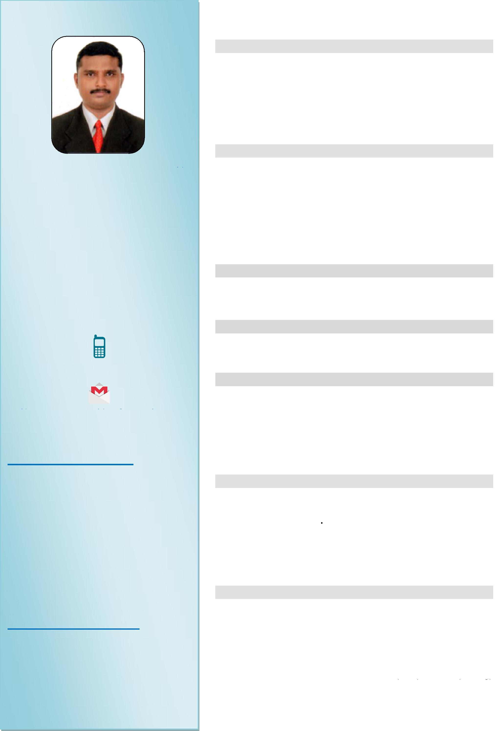

**Date of Issue**

**:**

**23/10/2019**

**Date of Expiry : 22/10/2029**

**Place of Issue : Trivandrum**

**RESUME**

**OBJECTIVE**

**To realize my potential in a dynamic organization, where I can fulfill my ambitions in the chosen field utilizing my skills, can contribute directly to the growth of the organization and in turn to my career.**

**SKILLS**

* **Self Confidence & Patience.**
* **Comprehensive Problem Solving Ability**
* **Responsible & Hardworking**
* **Effective Leadership Qualities**
* **Dedicated to profession adaptable service & support**

**EDUCATION QUALIFICATION**

**~ High School**

**COMPUTER KNOWLEDGE**

**~ Tally ERP9**

**EXPERIENCE**

* **15 years Experience as a ACCOUNTS AND CASH SECTION in Sri Stores, Kollam, Kerala.**
* **20 years Experience in DRIVER [LMV]**

**DECLARATION PASSPORT DETAILS**

**DECLARATION**

**I hereby declare that the above mentioned details are true and correct to the best of my knowledge and belief.**

**PERSONAL DETIALS**

**Gender : Male**

**Date of Birth : 21/02/1982**

**Marital Status : Married**

**Nationality : Indian**

**Religion : Hindu**

**LANGUAGES KNOWN**

* **English**
* **Malayalam**
* **Tamil**

[vijaya-405031@2freemail.com](mailto:vijaya-405031@2freemail.com)

**VIJAYA**

**LEKSHMINADA,   
CUTCHERY P.O.,   
KOLLAM - 691 013   
KERALA, INDIA**

**+971504753686**