abdul-405040@2freemail.com

+971504753686

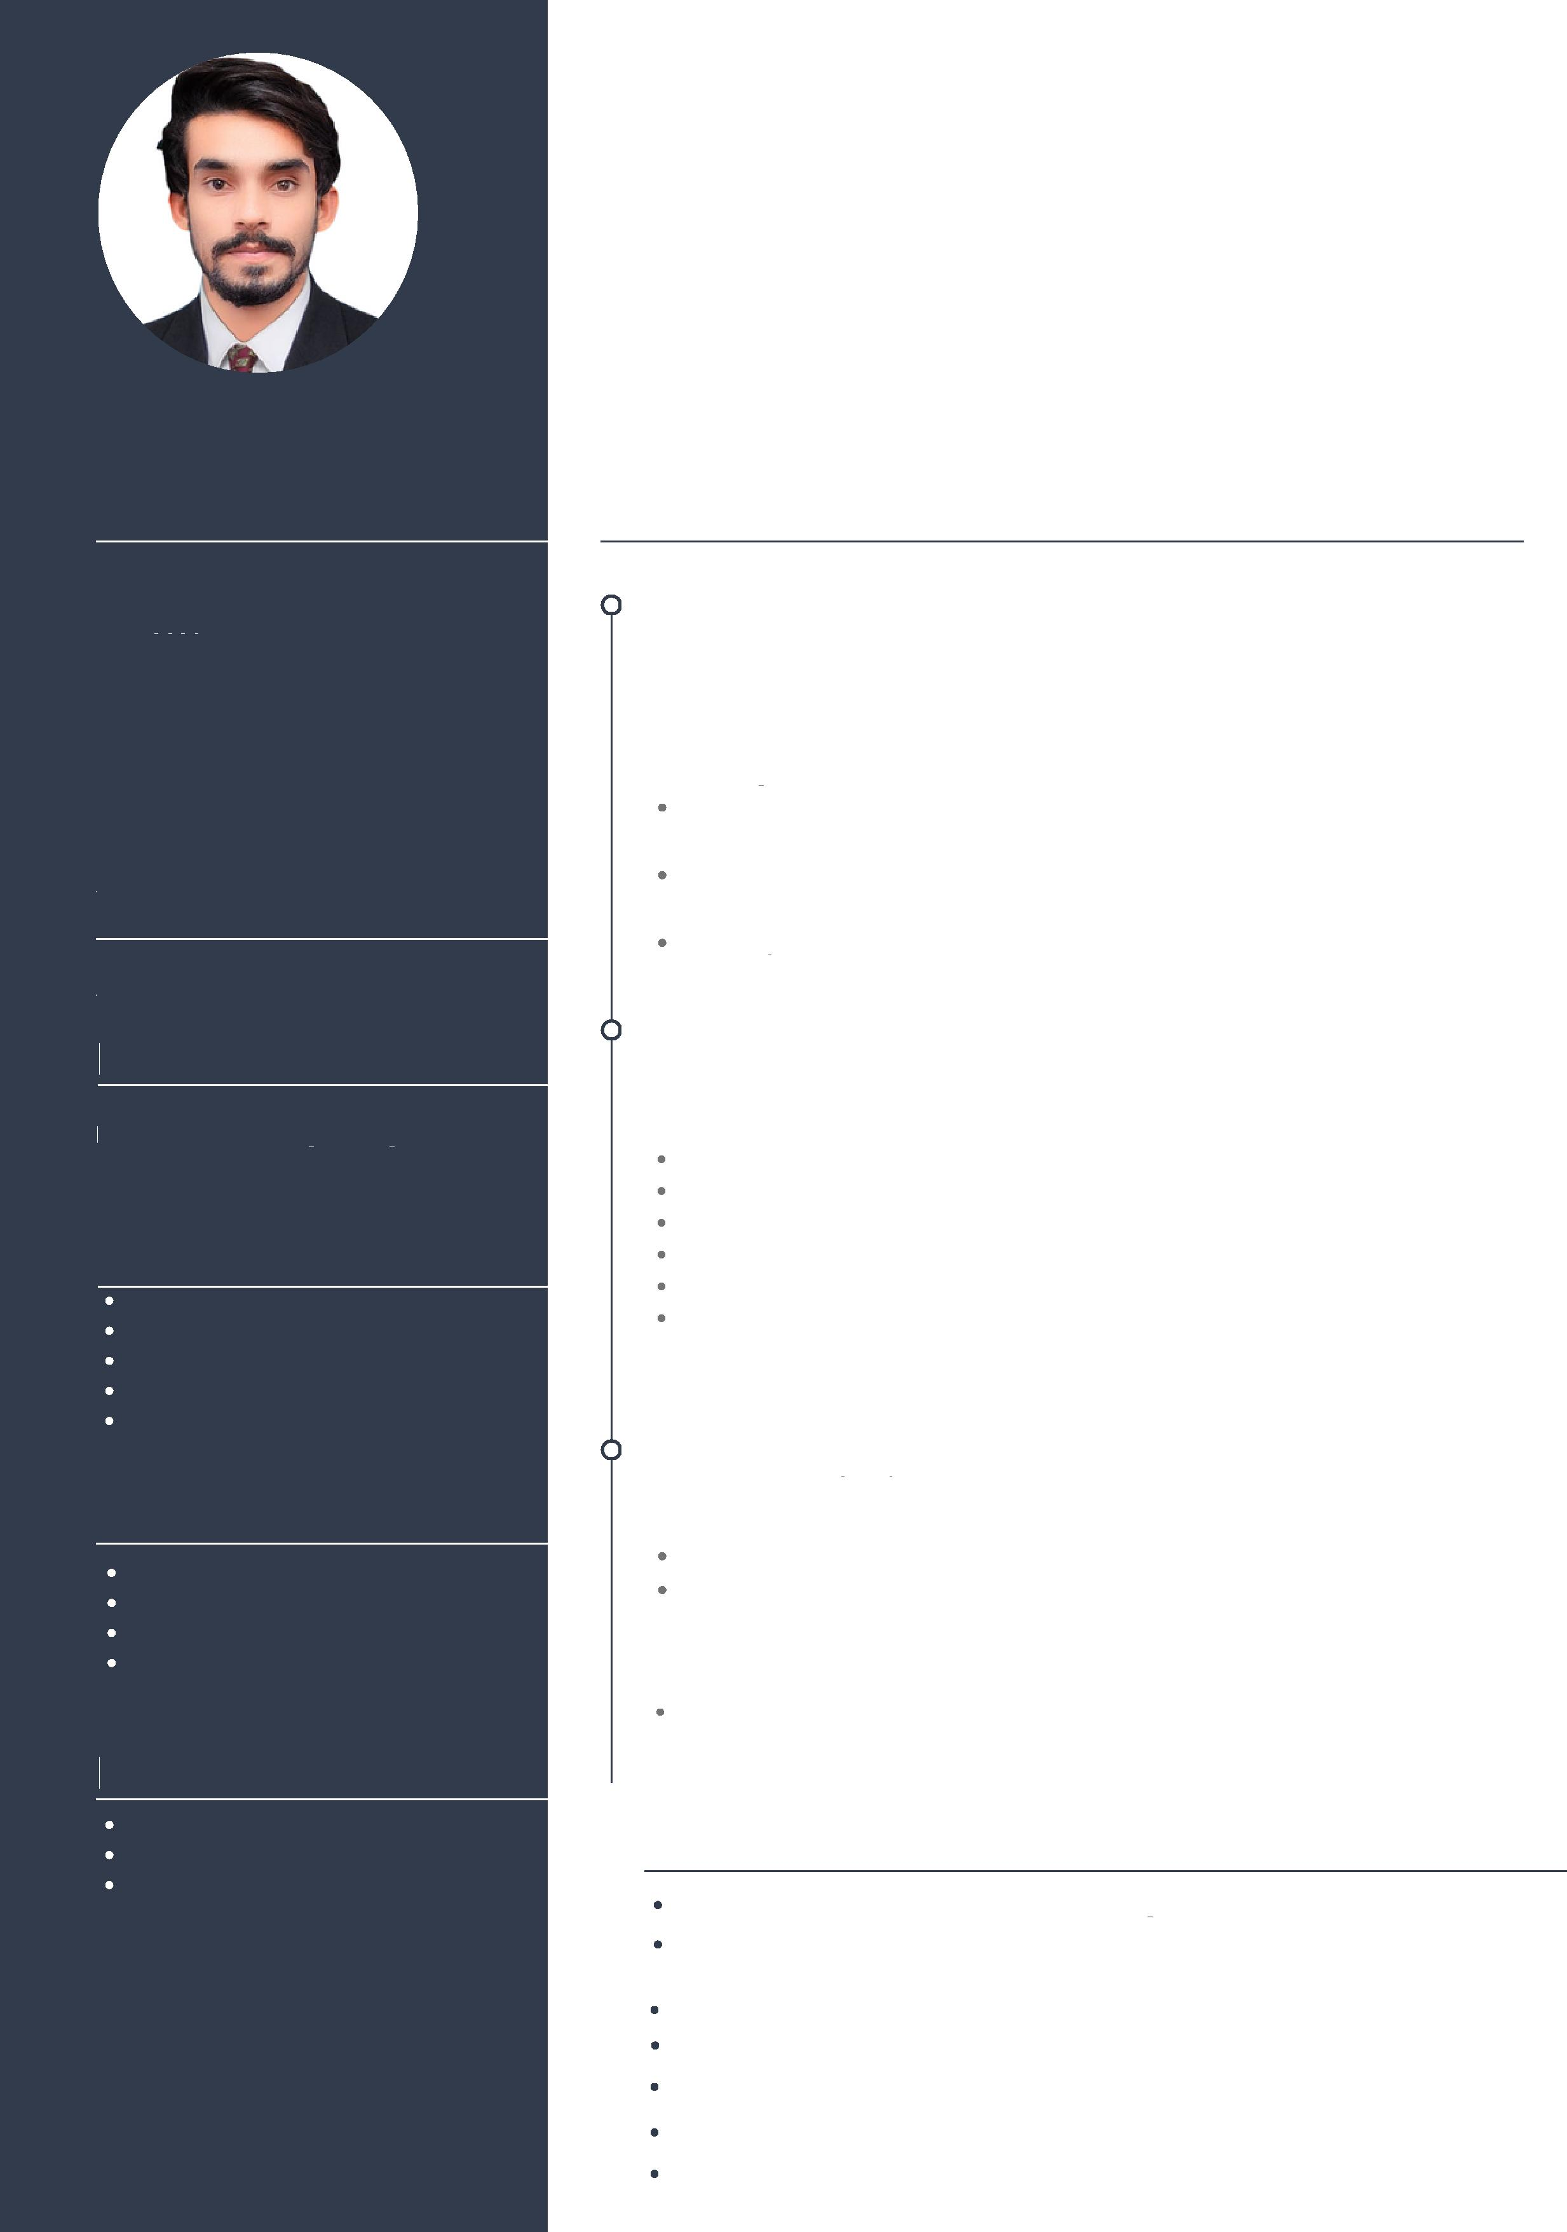

**Education**

**Abdul**

**Civil Engineer**

Professional Civil Engineer Knowledgeable and self-driven junior engineer with one year experience in quantity estimation with analyzing structural & architectural drawings. Knowledge of multiple Civil Engineering Software programs with strong attention to detail & accuracy. important ability to work & perform well independently or in a team. confident to face challenges

**Experience**

**Contact**

**Phone**

06/2022-12/2022

**Junior Engineer**

Working As Quantity Estimation engineer on the project of Khalid Abad Govt Girls College Moro

Quantity Estimation of Building Materials including (concrete, steel, cement, aggregates, sand)

Prepare Bar bending schedule (BBS) as Per Structural Drawings Including (Footings, Columns, Beams)

Bill of Quantities On MS Excel

01/2022-06/2022

**Email**

**Address**

DUBAI, United Arab Emirates

**Visa Status**

Visit Visa

**Trainee Civil Engineer**

Learn how to manage the man power for the construction activities Proper Management of Materials and workmanship

Conversant with architectural & structural drawings

Ensure the work flow according to work schedule

Co-ordination with departments staff

Supervision/Execution, checking and assuring that the construction is as per the final

10/2022-11/2022

Osmani & Company (Pvt.)Ltd

**One Month Training on Revit 3D Software**

3D Modeling Of Buildings 2D,3D Plans & Elevation

06/2019-07/2019

**Pakistan Civil Aviation Authority**

4 Weeks work experience regarding maintenance of runway at Civil Aviation Training institute (CATI), Hyderabad Airport

**10/2017-12/2021**

**Bachelors of Civil Engineering**

**Mehran University of Engineering & Technology Jamshoro**

**Soft Skills**

**Communication Skills Dedicated**

**Confident Creative Thinker Trustworthy**

**Technical Skills**

Revit 3D MS Excel MS word MS PowerPoint

**Languages**

Certificates

One Month " Autodesk Revit Essentials Training" (Revit 2020)

08 Days Surveying Camp at Mehran University of Engineering & technology Jamshoro

One day training session on "Project Management"

One day training session on " BIM According to ISO 19650"

One day training session on "Site Execution"

One day training session on " Soft Skills"

One day training session on "Executive Communication"

**English Urdu Sindhi**