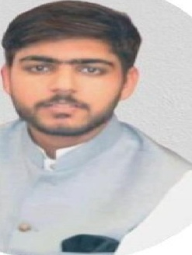 |  | Skill Highlights
 |  | - Microsoft, PowerPoint, word and excel.  - xperience | - Maintenance of Electrical Appliances All Solution
- Electrician : 4 Year Experience Point & Electric Works.
Tayyab

Objective
To persue a career in a progressive organization that provides for career growth, professional developement and also in order to groom to overwall personality.

- Assistant Supervisor : 1.5 Year Experience (Dispatched) and Quality Inspector at style Stylo thermopole foam Industry Lahore.

Contact
Phone: +971504753686
Email: tayyab-405042@2freemail.com
Languages
English Urdu
Hindi
- Ac Technician : Doing work Sargodha Madina Electronics
- ducation
- Matric Govt High School - 2014
- I.C.S Phisics Ambala College Sargodha - 2016
- BS Statistics : Sargodha University, PK — 2020
Certifications
- Matric (certificate): From Govt High School
- I.C.S Phisics : (certificate): From Ambala College Sargodha
- BS Statistics : (certificate) From Sargodha University, PK
- Repair & Maintenance of Electrical Appliances : (certificate): From Punjab V.T.I Govt. Punjab
Hobbies
- Playing Sport Game
- Reading Books of all kind
- Photography
- Design
- Auto Electrician : (certificate) From Govt. TEVTA College
- Safety Inspector: (certificate) From P.B.T.E.Lahore

