Veenashree  HACCP LEVEL 3 CERTIFIED / ISO 22000 /ISO 9001 CERTIFIED | 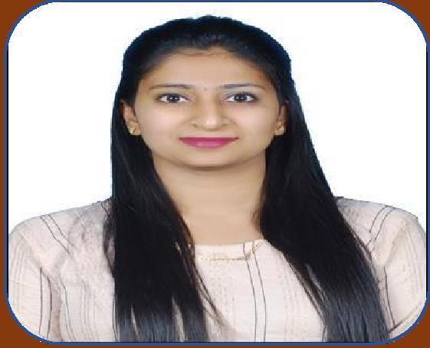

OBJECTIVES: Energetic and versatile BSc graduate with a genuine interest in implementing and maintaining best practice and safety standards for food/water/chemical business; and contribute positively to the growth of the organization. Passionate about working as lab assistant/CHEMIST/ QC/QA/FOOD SAFETY CONTROLLER / MICROBIOLOGIST /FOOD TECHNOLOGIST

CONTACTS
Burdubai
+971504753686
veenashree-405067@2freemail.com
PERSONAL DETAILS
DATE OF BIRTH – 23/02/1999 NATIONALITY – INDIAN
MARRITAL STATUS -MARRIED VISA STATUS – VISIT VISA

SKILLS
> LABORATORY SKILLS > HACCP
> MICROBIOLOGY
> BIOTECHNOLOGY
> BIOCHEMISTRY
> MS OFFICE
> ISO 22000
> ISO 9001
> GEL ELECTROPHORESIS
~ PCR
~ BLOTTING
~ DNA ISOLATION
IV ATTITUDE
> GOOD MANUFACTURING PRACTICE (GMP)
> GOOD LABORATORY PRACTICE (GLP)
> STAINING TECHNIQUES
HOBBIES
> PLAYING CHESS
> LISTENING TO MUSICS > COOKING

LANGUAGES
ENGLISH - FLUENT HINDI – FLUENT
KANNADA – FLUENT TULU – NATIVE
STRENGTH
POSITIVE ATTITUDE
GOOD COMMUNICATION SKILLS
SELF MOTIVATED HARDWORKING TEAM WORK
PATIENCE

EDUCATION

QUALIFICATION | YEAR OF PASSING | GRADE
BSc – Biotechnology, Microbiology, Biotechnology. | 2021 | CGPA – 8.79
HSC – (Science – PCMB) | 2018 | 87.6 %
SSLC | 2016 | CGPA - 9

CERTIFICATION
- HACCP LEVEL 3 – UK
- ISO 22000 – USA
- ISO 9001 – USA
EXEPRIENCE
ROLE – lab assistant in food lab
COMPANY: LABORATORIES, MYSORE ,INDIA . DURATION – OCTOBER 2021 to NOVEMBER 2022.
THEORITICAL AND PRACTICAL KNOWLEDGE
Operation of lab equipment’s like Laminar Air Flow, Incubator,
Autoclave, Hot Air Oven, Microscope, Weighing balance, Hot plate, electrophoresis,titration
- Microbial analysis of Food Total plate count agar, E. coli, Coliforms, Yeast , S .auers ,Salmonella,Yeast and Mold in foods.
- Analysis and evaluation of food and water sample to monitor the microbial load in finished products to ensure the product is not contaminated.
- Chlorine level test for drinking water
- Hardness testing of water
DECLARATION
I hereby declare that all the above details are true and correct according to my knowledge and belief.

