Gulfjobseeker CV 405153
Instrumentation Engineer

About Me

My Contact

cv405153@2feeemail.com
+971504753686
DATE OF BIRTH: 23-02-1999 SEX: MALE
NATIONALITY: INDIAN MARRIED STATUS: SINGLE RELIGEON: MUSLIM

PLACE OF ISSUE: INDIA(KOZHIKODE)
A Customer-friendly, sedulous, work dedicated and quick learner person, who always aims to put his best in doing his works and to establish good relationship with his co-worker. With over one & half years experience as a Automation engineer in maxwell distributors pvt ltd (eglu automation)

Experience
eGlu Automation pvt ltd.
April 2020– December 2022

Responsibility

In view of your office, you must effectively perform to ensure results. Your performance would
be reviewed as per the Company’s Performance Management System. Handling the installation,
Demo & Training function activities of eGlu Brand Home and Office Automation in the assigned
territory.

Achievements

Skill
Language

Observation Decision making Communication Multi-tasking

English hindi malayalam Tamil Arabic
Kerala State Electronics Development Corporation Ltd. (KELTRON)

Job Related Training Course Attended

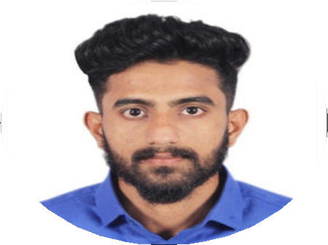Education Background

BOSIET
Basic Offshore Safety Induction & Emergency Training 2022

H2S
Hydrogen Sulphide Safety 2022

INDIRA GANDHI POLY TECHNIC COLLEGE
Diploma in Instrumentation and controlling, Completed in 2019

I K KUMARAN GHS SCHOOL
Secondary School Leaving Certificate Completed in 2014
STCW TRAINING COURSE

- Elementary First Aid.(EFD)

- FIRE survival Techniques(FST)

- FIRE Prevention and FIRE Fighting(FPFF)

- Personal Safety and Social Responsibilities(PSSR)

- Security course(STSDSD)

Contact us to interview / hire this candidate
