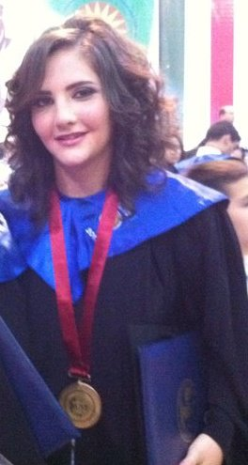
MIRNA
MIRNA.42756@2freemail.com

Personal Statement:
A business management graduate from the American University of Science and Technology. I have skills and knowledge essential as customer care and Human Resources assistant manager.

Education:
1993—2006: Notre Dame de la Delivrande Araya (Bacc II Science de la vie)
Fall 2007 till Fall 2011: BS in Business management in AUST university Ashrafieh
Major courses emphasized on:
- Project management
- Managerial accounting
- Cost accounting
- Taxation
- Operations management
- International marketing
- Human Resources Management
- Employee Relations Management
Work Experience:

February 2015 till present: HR and administration at Exceed Resources
Key Responsibilities: responsible for all visas and insurance for all employees worldwide.
February 2013 till February 2015: HR administrator at MAN enterprise.
Key responsabilities: administration work related to the construction site, assisting the project manager, daily manpower attendance reports, monthly reports, leave authorizations, NSSF...

July 2012 till December 2012: HR coordinator at AP Moller, Maersk Line company, Beirut Gemmayzeh.

Key Responsibilities: taking attendance, compensation and benefits, SAP system invoicing, screening CVs on myHR system the e-recruitment, daily reports reporting directly to the Human Resources Manager, dealing with embassies for Visas, dealing with hotels for conferences and events, NSSF and all governmental papers for employees.

September 2010 till July 14, 2012: HR administrator at Mobi Cedarcom Group Salim Salam

Key responsibilities: screening CVs, doing first interviews, administrative work, daily reports about what happened during the day because we had two branches for Mobi (the head office and the technical team and I was handling the technical team and reporting for the head office daily reports), taking attendance, getting customers complaints and do reports about them.

May 2010 till August 31, 2010: Sales woman at Sport et Loisir- Tabaris

Interests:
Human resources: as I am a business management student, and I have a healthy background in human resources, I would like to continue in this field to become an expert and benefit from every professional experience.
Sports: I believe a healthy body is the key to a focused mind in today’s hectic society.
Living life: We only get one shot at this life so I aim to get the most out of it. I love swimming; travelling to different countries, sky diving…
Skills:
Computing: MS word, excel, power point, internet explorer, SAP and FACT system, My HR system…
Languages: English (fluent), French (Fluent), Arabic (Fluent) and Spanish (beginner)

