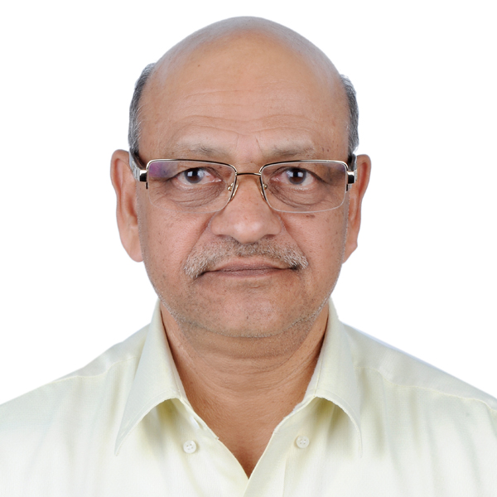
Rajendra
Doha, Qatar. E-mail: rajendra.44208@2freemail.com

Senior level Mechanical Engineering professional with more than 42 Years International experience and strong exposure in Project & Industrial Management seeking a senior level assignment cutting across industries.

Senior Management Position
Advanced knowledge and experience in Management of complex projects & industries with all relevant monitoring & control systems, standards. I possess excellent ability to strategize various aspects & steps in a complex project or industrial process so as to achieve target objectives with desired quality and costs. Proven ability to head any organization at corporate level; designing, implementing, communicating, coordinating and providing overall technical and administrative direction on all relevant decisions, which bear critical importance to achieve the overall globally acceptable objectives, operations, and profitability.

Expertise in  - Large scale project system planning/designing.  - Finalizing project equipment selection criterion  - Equipment selection  - Equipment procurement  - Equipment erection  - Project / equipment commissioning  - Operation & Maintenance of project / industry.  - I have maintained continuous process industry with ZERO breakdowns for long duration.  - Handing over the project to the client.  - Taking over the project from the consultants.  - Implementing renewable energy schemes.  - Implementing energy conservation plans  - Project Quality Management  - Training and Development of staff  - Project Documents Review  - Project KPIs Development  - Project Risk Management  - Team Management/Leadership | Leadership Strengths & Highlights  - I am a GCC countries experienced Mechanical Engineer in Utilities services & specializing in Refrigeration & air-conditioning district cooling services for hospitals, residential, commercial & industrial applications.  - I have also worked in GCC countries as lead management personnel for the overall management of operation and maintenance cum up-gradation contracts / services for comprehensive hospital, residential & commercial Utilities services comprising of HVAC, Electrical, Civil, Plumbing, Firefighting, Mechanical, Elevators, Laundry & large kitchens.  - I have worked on waste water pumping & treatment systems.  - I have knowledge of different types of water treatment, RO plants & their related pumping facilities.  - I have experience in the selection, installation operation & maintenance of Diesel engine operated captive power generating systems.  - I have worked on liquid Nitrogen, Oxygen & medical gases generation & processing plants, their storage & handling systems.  - I have also worked on industrial air drying units capable of drying air up to a dew point of -40 degree C.  - I have exposure in operating & maintaining central vacuum systems operating in hospitals & various industries.  - I have experience in operation & maintenance of steam generating boilers, steam distribution & condensate recovery systems with their related pumping facilities of industrial, commercial & hospital services.

Key Functional Skills

- Implement all relevant applicable standards and policies of the company
- Deliver and execute strategic plan to achieve results & customer satisfaction across the table.
- Develop & revise management system documentation, methods to improve overall project standards & customer satisfaction.
- Monitor & establish Weekly & Monthly reports duly satisfying organizational audit program.
- Lead in devising and preparing relevant tools to monitor overall work activities, progress & statuary laws of the land.
- Introduce Performance Management by utilizing corresponding measuring/monitoring tools.
- Establish documentation and filing system as per company quality system & procedures
- Ensure & co-ordinate for implementing Quality management programs in compliance with organizational practices.
- Lead audits checklists; follow up actions, maintenance of audit records as per client and corporate requirements / practices.
- Propose preventive measures, promote and implement improvement programs, analyze & prevent non-conformances.
- Lead in managing company document system ensuring its maintenance and updates as per company procedures.
- Train all personnel on computerized material management & maintenance planning programs based on Maximo.
- Training subordinates for developing & setting up of plant routine & regular technical standards/procedures for smooth & cohesive interpersonal working resulting in overall improvement of the overall efficiency.

Performance appreciation by various Employers
I have been re-employed by four (4) different employers in India, Kuwait & UAE based on my exceptionally outstanding performance. Some of the employers had even revised their management policies in order to accommodate & recruit me again.

Professional Experience

Resident Engineer with Parsons International Limited, Doha. - Qatar • Sep 2011 till date
Parsons International is Project Construction Supervision Consultants appointed by ASHGHAL in Qatar.
Responsibilities
- Manage equipment selection, overall supervision of their installation, commissioning, facilitate the comprehensive handover of the up-graded pump stations to Ashghal Operation & Maintenance Department.
- Ensure that the overall project is supervised such that it is completed with acceptable quality & within the time schedules.
Projects Involved
- Overall up-gradation of several waste water pump stations with their relevant rising mains as per the concept design provided by authorized design consultants.
Accomplishments
- This up-gradation work is completed with quality acceptable to all the stake holders within the allocated time schedules.

Resident Engineer with Parsons International Limited, Dubai - UAE • September 2010 – August 2011
Parsons International is project construction supervision consultants appointed by Tabreed / Dubai Metro in UAE.
Responsibilities
- Manage overall supervision of the installation, commissioning of the chilled water ETS stations along with their chilled water piping connecting these to their central chiller stations. These were used for air-conditioning of the multi-level metro stations.
- Ensure that the overall project is supervised such that it is completed with acceptable quality & ahead of the time schedules.
Accomplishments
- This up-gradation work was completed with quality acceptable to all the stake holders ahead of the allocated time schedules.

Maintenance Manager with Palm District Cooling, Dubai – UAE • October 2005 – September 2010
Palm District cooling was a member or Dubai World Group of UAE.
Responsibilities
- This is the world’s biggest district cooling company having an installed capacity of 414,000 TR under one umbrella.
- I have the credit of expanding the maintenance department of this company from my solo presence to strength of 165 nos.
- I was lead personnel involved in taking over the various district cooling stations from the consultants / contractors.
- I was responsible in implementing renewable energy plans, economizing on the operational costs of the central chiller plants.
Accomplishments
- Developed and implemented all policies and procedures for all operations of the district cooling plants successfully.
- Devised various procedures, operation & maintenance routines such that all the plants operated at their optimum or even better efficiencies.

Previous Experience
- Project Manager | Gulf Industrial Services Co; Abu Dhabi for Abu Dhabi National Oil Co. (ADNOC) 2004 – 2005
- Project Manager | Engineering Maintenance Co; Abu Dhabi for Abu Dhabi National Oil Co. (ADNOC) 1998 – 2004
- Resident Engineer | Badar Al Mulla & Bros. Kuwait 1993 – 1998
- Project Manager | Samcor Glass Ltd. India 1990 – 1993
- Resident Engineer | Saleh Jamal & Co. Iraq 1990 – 1990
- Deputy Manager (Utilities) | Samtel India Ltd. India. 1989 – 1990
- Chief Engineer | Modern Woolens Ltd. India 1986 – 1989
- Works Manager | Brahmani Cement Udyog, India. 1985 – 1986
- Utilities Engineer | Orkay Polyester Ltd. India. 1982 – 1985
- Assistant Mechanical Engineer | J. K. Synthetics Ltd. 1975 – 1982
- Trainee Mechanical Engineer | Jaipur Metals & Electricals Ltd. India. 1974 – 1975

Credentials
Education
- Bachelor of Science (B. Sc.) in Mechanical Engineering from Kanpur University (HBTI), – India in 1974

Computer Literacy
- Familiar with MS Office applications

Personal Particulars

- Date of Birth: July 26, 1953.
- Languages Known: English, Hindi
- Nationality: Indian
- Marital status: Married
- Passport valid till 30/11/2025
- Driving license: Holding valid Qatar, UAE driving license.

