Sowmya

Sowmya.46608@2freemail.com
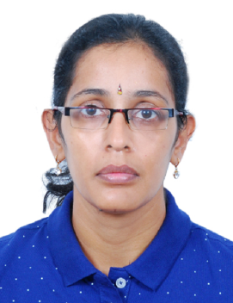

Career Objective

To get a challenging and responsible position with growth opportunities, under a well growing management which can provide me the platform where I can improve my ability and build a bright career.

DESIGNATION

JUNIOR ACCOUNTANT

WORKED COMPANIES

COMPANY NAME PERIOD
*M/s. Lamprell, Sharjah August 2008 to November 2008
* M/s. EuroPack Trading Est Ltd,
Bur-Dubai December 2015 to December 2016
* M/s. Lakshmi Engg Products,
Coimbatore, India April 2006 to April 2007

JOB RESPONSIBILITES

- Invoice Verification.

- Data entry invoices to MS Excel.

- Processing supplier payments.

- Maintaining and updating book for petty cash fund.

- Preparation of LPO

- Bank transactions – Deposit of cheques, Supplier payments, etc.

- Bank reconciliation.

- Preparation of salary statement and issue of pay slip.

- Preparation of Customer statements and follow up for payment
- Prepare journal entries.

- Conduct physical verification of inventory.

Educational Details

ACADEMIC/TECHINCAL QUALIFICATION

- B-Com
- MBA HR (undergoing)
Working knowledge

- Tally (Accounting Software)
- MS Office – Word, Excel, etc.
- Experience in working with internet, E-mail.

Other Activities

- Member of National Service Scheme Awarded First Prize in Carrom and Ball Badminton in college level.
- Participated and presented a paper in National level Seminar “EMERGING TRENDS IN HRD” in Kovai Kalaimagal College of Arts and Science.
- Participated and presented a paper in Inter College Seminar “COLLABORATIVE COMMERCE” in Sri Krishna College of Arts And Science College.

I here by declare that the above information provided by me is correct to the best of my knowledge.

