Sriram
E-Mail: sriram.48943@2freemail.com
Senior Level Assignments
Procurement & Purchase Operations
Industry Preference: Retail
Location Preference: Dubai, Sharjah, Ajman
sri123_ram@yahoo.co.in +971 504852256
Key Skills  Procurement  Supplier Management  Stock Verification  Vendor Performance  Price Variance  Reporting & Documentation  Liaison & Coordination  Stock Management  Process Enhancement | Result oriented professional with recognized proficiency in Buying procedures with an aim to accomplish corporate plans & goals successfully.
 | Profile Summary:
- Dynamic professional with 8 years of experience; currently associated with Home Centre (Land Mark Group) as Procurement Assistant.
- Proficient at building and maintaining vendor relations; evaluating vendors, managing buyer processes, and analyzing reports.
- Skilled at recommending the implementation of a tracking form for short-paid invoices, eliminating supplier invoice resubmissions to increase the efficiency of the Accounting Department.
- Experience in purchasing function for the procurement for series supplies and new product development & supplier quality assurance.
- Coordinated with production and logistics department for requirements; evaluated suppliers and negotiated on prices and purchase agreements
- Managed overall operations and enhanced the operational efficiency by eliminating obsolescence and achieving cost reduction through vendor development, curbing rework & rejection, materials management and inventory control.
- Extensive experience in managing stock level by rejecting materials found non-conforming to identify a course of action for disposition of disclosed ones.
- A keen communicator with honed interpersonal, problem solving and analytical skills.

Soft Skills | - Career Timeline:
Collaborator  Communicator  Planner  Change Agent  Motivational Leader  Thinker | 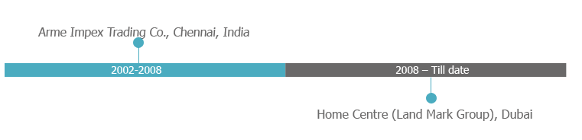  2003-2005  2003-2005  Education:  - M.Com. from University of Bharathidasan, Trichy, India in 2005  - B.Com. from University of Bharathidasan, Trichy, India in 2001
Work Experience | Home Centre (Land Mark Group), Dubai as Procurement Assistant.  Role:  - Coordinating with Planning Department regarding the order details.  - Requesting Proforma invoice from supplier as per requirement and verifying the same.  - Creating and verifying purchase order and getting approval from respective buyer; sharing order confirmation with suppliers.  - Managing activities related to shipment date changes, Qty & distribution changes; connecting with suppliers and updating the order status.  - Drafting carton marking details and corresponding to the suppliers.  - Confirming assembly and packing structure for all new items.  - Checking existing stock for the assembly in structure and packaging; reporting issues related to AI and packaging and informing the same to supplier for the necessary action.  - Examining all samples and sharing feedback with the supplier.  - Coordinating the completion of sample collections for Buying Director and Merchandiser.  - Supporting Buying Director in managing and coordinating the buying activities for every season with all the supplier.  - Providing administrative assistance to Buying Department including Buying Director, Senior Buyer and Merchandiser; keeping filing system brand wise for Buying & Merchandising Department.  - Preparing cost pricing sheet; Giving to senior buyer for checking the price, Whatever revised price uploading (along with item code, Location ) in ORMS System; Once update Revised price getting approval from senior buyer and finance dept; sending to concern territory and updating the status.  Accomplishments:  - Worked as core member of:  - Shipment tracking system online implementation that reduced paper works & enhanced process flexibility.  - Cost pricing System online implementation that reduced paper works & enhanced process flexibility.
2008 till date

2002-2008  Personal Details  Date of Birth: 14th November 1980.  Languages Known: English, Tamil and Hindi.  Nationality: Indian.  Visa Details: Residence.  Marital Status: Married. | Arme Impex Trading Co., Chennai as Import Assist-Import Documentation and Clearance process.  Role:  - Collaborated with:  - Suppliers to obtain copy and original shipping documents on time; followed up with them for pending order status.  - Liner to clear the shipment within deadline.  - Examined copy of shipping documents such as bill of lading, commercial invoice, packing list and certificate of origin.  - Maintained shipment records with ETA dates.  - Tracked pending documents through weekly progress records.  - Connected supplier to get revised shipment documents.  - Assisted Post Clearance Team with on time shipment clearance to avoid demurrage charges.  IT Skills:  Packages: Microsoft Office 2010 & Effective handling in WEB search tools.  Operating Systems: Windows XP, Windows 7, windows 8, windows 10.  Application: ERP-Oracle Application & SCP.

