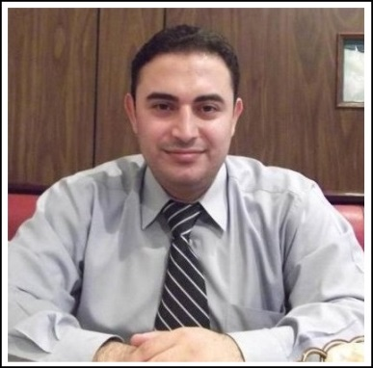
Sameer
Sameer.7401@2freemail.com
CV
EDUCATION
Bachelor of Sports Sciences & Physical Education
Faculty of Physical Education (Tishreen University) Lattakia- Syria

PROFESSIONAL EXPERIENCE

Fitness Club Manager&North Emirates coordinator
Al Qudra Sports Management Company (AD) 2005 -2010
Responsibility
- Responsible Follow-Up For North Emirates Clubs In
-Dubai - Sharjah - Ras Al Khaimahand Fujairah
- Weekly and monthly Reports to Operating Manager ( members - Sales - Contributions -Maintenance - Safety Tools)
- Daily check for the safety of the swimming pool water
- Personal training
- Supervision of training,
- planning for training and annual plans with trainers
- Following up records of members and subscriptions
- Timing work hours and the departure of staff.
- Following up faults and periodic maintenance for the sports equipment

Sports Project Manager

Dubai Al Garhood
Sports Village L.L.C part of K.A.A.S Group August 2010>>>
Sports Project Manager
Sports Management, Marketing ,Training , Consulting , Projects Management

PRACTICAL PARTICIPATION
- FINA. 4th finaWorld Junior Swimming Championship Dubai 2013(Executive Committee)
- FIFA.World Cup U-17 UAE 2013(Executive Committee)
- Special Olympics Middle East Football Unified Cup 2013 (Executive Committee)
- 4th International Conference ( Sports Versus Crime)Dubai 2013
- Dubai International Marathon 2014
- Championship in powerlifting - Syria (1998 -2001)
- Tournament First Military Athletics GCC2006(Executive Committee)
- (Dubai Pulse) Dubai 2013 – 2014 ( Dubai sports council )
TRAINING COURSES
 | Sports management institutions - Events organizing  Time Management - writing reports - Marketing | 2014 Dubai Sports Council
 | First Aid And Emergency Response Program.SANID | 2014 Emirates foundation
 | Projects Managements 2013 | (UMC RESEARCH) Dubai
 | Sports Marketing | Al Qudra Sports Management
 | Timing Management 2009 | (MOGUL)
 | General English Courses | (international language center)
 | Administration In Sports Organizations 2012 | (Leaders Qualification Center) Dubai
 | Referee athletics | UAE ATHLETICS FEDERATION
 | Bodybuilding trainer 2013 | (leaders qualification center) Dubai
 | Training in Techno-gym sports company 2009 | (Abu Dhabi)
 | Training in Life-fitness Academy 2008 | (Dubai)
 | Course Sports medicine and Football | (Damascus)

SKILLS
- Excellent communication, Public Relations & interpersonal skills.
- work team leader skills
- Strong organizational and follow through skills
- Good customer service & marketing skills
- Internet & computer skills MS office

