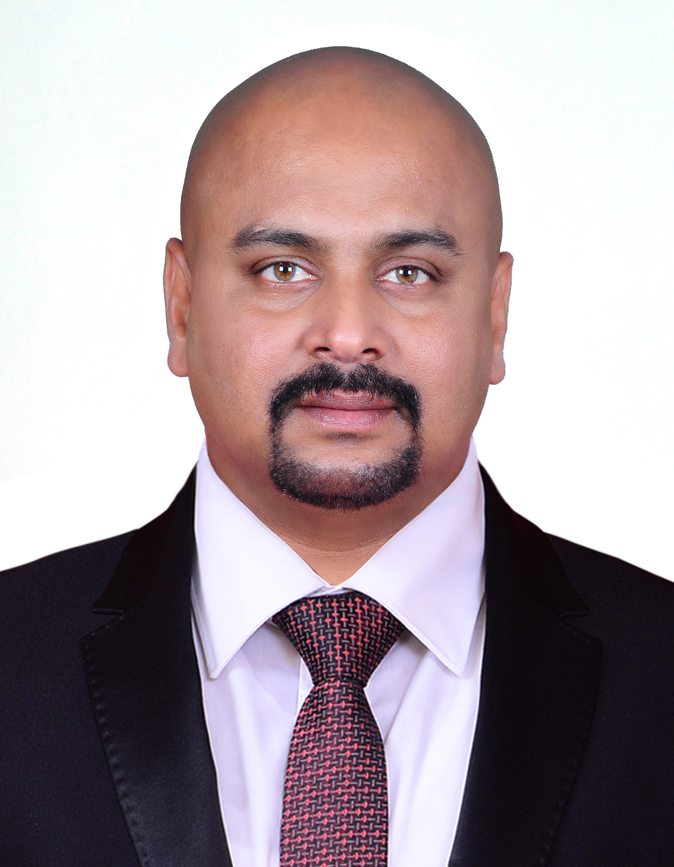
GIRIDHAR. Giridhar.74751@2freemail.com
Phone: C/o 0505891826

 | “Experience is knowledge but with vision, it is creativity.”
Career Objective | To progress in life in a professional manner, highlighting the need for development and achievement in my career, further helping the organization to reach the focused goal.
Personal Profile | Self motivated, innovative, diligent with lot of initiative & drive. Cheerful, pleasing personality with an optimistic attitude.
Professional Qualification | MBA - Masters in Business Administration; Madras University, India.
Academic Qualification | B.Sc - (Bachelor’s degree in Physics) - Manonmaniam Sundaranar University, India.
Computer skills  Professional  Experience  Professional  Experience | Sound knowledge in implementation of SAP –SD E.C.C 6.0. Proficient in MS Office (MS Word, MS Excel, Power Point,), Internet & Email  (August 2011- Till Date) Gulf Business House International.—UAE Till Aug 2016.  From Sep-2016 Till date – Muscat ,OMAN  CIVIL /M.E.P Contracting Division  Business Development Manager  - To identify and promote sales opportunities within designated territory  - Make contacts with potential Consultants, Clients, Contractors and generate enquiries for COMMERCIAL & RESIDENTIAL BUILDINGS, VILLAS, (CIVIL/MEP) /INFRASTRUCTURE & INDUSTRIAL construction works.  - Responsible for generating enquiries / submission of quotations/ tenders/ negotiations and finalization of contracts...  - Coordinate with the Operations Dept. on the execution of Contracts  - Responsible for invoicing and collection of payments .  (June2010- July2011) LaticreteRAK- Abudhabi-UAE  Tile Adhesives, Grouts, Water Proofing Materials, Screeds, Mortars & Sound Proof Materials  Technical Sales Executive  - To identify and promote sales opportunities within designated territory  - Make contacts with potential Clients , Consultants, Architects, Civil Contractors, Stone & Marble Contractors and analyse their requirements for Tile Adhesives, Grouts, Waterproofing, Screeds, mortars and Sound Proof Materials...  - Responsible for generating enquiries, Submittals, Sample approvals, Mock-up’s, submission of quotations/ tenders/ negotiations and finalization of contracts/Materials.  - Additional responsibility in finalising Sub-Contracts for Application works for Waterproofing , screeding and Tile fixing  - Responsible for debt collection within the designated territory.
Professional Experience | (June2008- May2010) Belhasa Projects Llc- Abudhabi-UAE  Swimming Pool, Water Feature and Landscaping division  Sales Executive  - To identify and promote sales opportunities within designated territory  - Make contacts with potential Clients l Consultants, Architects, Contractors and analyse their requirements for Swimming pool, Water Features, and Landscaping.  - Responsible for generating enquiries/ submission of quotations/ tenders/ negotiations and finalization of contracts...  - Coordinate with the Operations Dept. on the execution of Contracts  - Responsible for debt collection within the designated territory.
Professional Experience | (Nov 2003-Jan 2008) Rain drops Pvt Ltd , Kerela, India.  Distributors for major branded consumer products like VGuard Fans, Water Heaters, Stabilizers, Dish T.V; Fancy Lights & Crocodile brand Garments.  Asst Sales Manager  - Involvement in Sales planning, Strategies and Forecasting  - Increasing market penetration by effective forecasting and executing strategic decisions in sales and achieved better sales targets by implementing effective marketing plans.  - Maintained market share of products and business development by analysing and cross-check competitor’s activity.  - Conducts visits to the retail operation stores within the state on a weekly basis.  - Driving business growth through aggressive business development initiatives that resulted in increased revenue growth.  - Reviewed market analysis in order to determine customer needs, volume potential, price schedules and discount rates.  - Managing and supporting the direct and van sales team to achieve their sales target  - Involved in implementation of schemes and promotional activities successfully.  - Exhibits creativity in suggesting valuable points in the arrangement of product visibilities and their location as well.  - Realized 100% payment from the market through effective monitoring of records  - Managing service centres and service teams.  - Providing quality service to clients on corporate levels.  - Ensure prompt after sales and warranty support for company products to the end users.
Professional Experience | (July1996-Oct 2003) Usha International Ltd, Cochin, India  Usha International Ltd is one of the leading marketing organizations in India. They are one of the market leaders for Fans and Sewing machines and had wide range of home appliance products, motor pumps, Air-conditions, U.P.S and Stabilizers in the brand name USHA.  Senior sales Executive  - Sales Planning & Forecasting  - Setting sales target  - Identifying potential Dealers and Distributors for network development  - Setting up new business and promotional activities through marketing campaigns, trade-shows, business expos and sales promotions  - Involved in implementation of schemes and promotional activities successfully.  - Managing and supporting the direct sales team and sales executives to achieve their sales target.  - Conduct monthly meeting to review the monthly sales plan and achievements  - Monitoring and controlling outstanding bills  - In-Charge of company showrooms in Kerala.  - Involved in implementation of schemes and promotional activities successfully.  - Providing demo to the clients and arranging product delivery etc.  - Maintaining good relationship with the sales staff, providing product training & Sales tips  - Examines and studies new products in their minute level to be efficient enough to handle customer queries to their satisfaction.  - Managing service centres and service teams.
Personal Traits | My strengths are better understanding, good listening skills, energetic, Go-getter, Hard worker, innovative, dedicated, love to work with strong sense of solidarity and patience. Confidence in working on a pressurised environment
A self starter | Office Management/Administration  Achieving Sales Target  Client service & co-ordination  Handling Sales Team
Technical & professional skills | Good exposure to Desk Top applications and MS Office  Basic knowledge of computers.  Proficient with SAP implementations.  Good administrative skill and professional confidence.  Can achieve positive result on negotiating table.
Other Area | Hard worker, innovative, dedicated, patient, can keep calm and work under pressure, can prioritise the jobs given and work accordingly
Nationality | Indian
Date of birth | 8th September1973
Languages  Passport Details | English, Tamil, & Malayalam  D.O.E- 28/10/2025
Visa Status | Residence Visa ( OMAN & UAE)
Extracurricular Activities | Music and Travelling.
U.A.E Driving Licence No
OmanDriving Licence No

