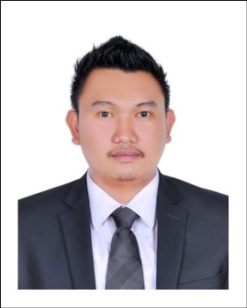

Gervin

Gervin.77996@2freemail.com

_____________________________________________________________________________________
Objective:

To be able to qualify for a position related to my field of specialization, which will serve not only as a career growth but also as a challenge to my profession.

Skills and Core Competencies:

- Customer Service
- Cashiering
- POS system
- Coffee Brewing
- Latte and Fudge Art
- Ms Office Application
- Coffee Blending

Work Experience:

Cafe Barberra/Black Iris Cafe
Supervisor
Dubai, U A E
November 2016 to present

Al hassim café
Supervisor/Barista
Dragonmart mall
Dubai, U A E
2009 to 2016

Duties and Responsibilities:

- Directly supervises operations during a shift to make sure that food handling and product preparation follows the company’s standard procedure.
- Assist customer needs and provides information regarding about the food that we prepared.
- Train workers in food preparation, and in service, sanitation, and safety procedures.
- Supervise and participate in kitchen and dining area cleaning activities.
- Take customer orders, maintain cash drawer, prepare sandwiches, desserts and other food items.
- Report directly to the store manager regarding product consumption and stock.

Al Bustan Bakery and Sweets
Warehouse assistant
Al qusais Dubai, Uae
September 2008 – June 2009

Duties and Responsibilities:

- . Receiving, moving, checking and storing incoming goods.
- Checking and inspecting goods received and ensuring they are of accurate quantity, type, and also acceptable quality.
- Packaging and labelling products before they are dispatched.
- Helping to ship out over 500 lines every day.
- Picking and packing products.
- Selecting space for storage and arranging for good to be placed in the designated areas.
- Making sure that all inventory processes are completed on the same day.
- Loading and unloading lorries, vans and other vehicles.
- Maintaining and servicing warehouse tool, machinery and trucks.
- Labelling goods that have arrived at the warehouse.
- Operating a forklift, boom truck and front-end loader.
- Welcoming and helping clients who visit the branch.
- Contacting transport companies and coordinating dispatch and delivery with them.
- Preparing deliveries for the van drivers.
- Moving and organising stock.

Educational Background:
B.S HOTEL AND RESTAURANT MANAGEMENT
The Fisher Valley College
Metro Manila, Philippines
S.Y March 2003-2007

Personal Information:
Civil Status: Single
Citizenship: Filipino
Date of Birth: April 03, 1989

I hereby declare that all the above information are true and correct.

