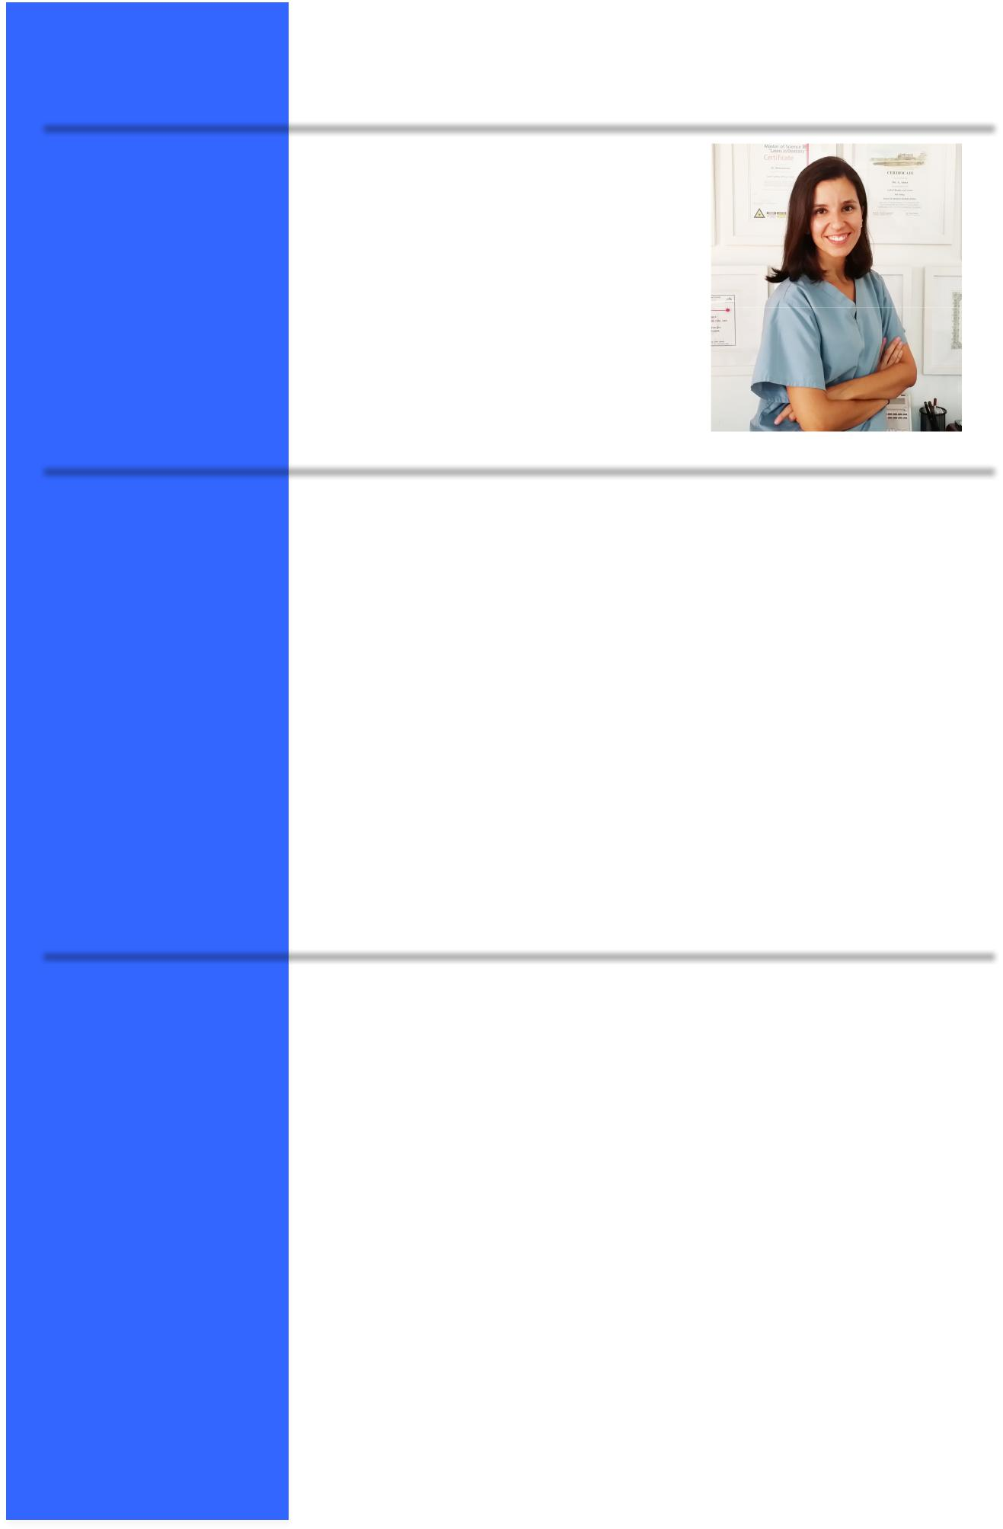 |  | Resume
Personal Details
 | Date of Birth: | 30/04/1985
 | Marital Status: | Married
 | Nationality: | Spanish
DHA |  | DHA license
Dentistry Education
 | Dates: | 2003 – 2008
 | Institution & Address: | Universitat Internacional de Catalunya, Barcelona – Spain
Post Graduate University Education
2014 |  | Degree in Restorative Aesthetic Dentistry
 |  | Universitat Internacional de Catalunya. Barcelona – Spain
 | 2009 – 2013 | Degree in Advanced Orthodontics CSW Technique
 |  | Ladent Institution (Dr. Echarri). Barcelona – Spain
Other Training
2012 |  | “Orthodontic treatment in Adults”
 |  | Institution & Location: COEC – Barcelona, Spain
2011 |  | BioQuick Self ligating System (Forestadent)
 |  | Institution & Location: Valencia, Spain
2010 |  | “Self ligating System. Review.”
 |  | Institution & Location: COEC – Barcelona, Spain
 |  | VI Barcelona Orthodontic Meeting
2009 |  | Seminars in Orhodontics
 |  | Institution & Location: COEC – Barcelona, Spain
 |  | Expo-­‐Orto Madrid

Professional Dentistry Experience

2015 | The DentalSpa – Private Dental Practice
 | General dentist, Endodontics, Cosmetic dentistry and
 | Orthodontics.
February 2015 | Volunteer work in Kenya with the non-­‐governmental organization
 | Dentistas sin Límites providing free dental assistance.
2011 – 2014 | Boix Dental Clinic – Private Dental Practice
 | Orthodontist
2008 – 2014 | Rais Dental Clinic – Private Dental Practice
 | Orthodontist, General Dentist, Endodontist and Aesthetic
 | restoration
2012 – 2013 | Millenium Sanitas Dental Clinic – Private Dental Practice
 | Orthodontist
2009 – 2013 | Núria Canals Dental Clinic – Private Dental Practice
 | General dentist, Endodontist and Aesthetic restoration
2008 – 2010 | Caredent Dental Clinic – Private Dental Practice
 | General Dentist
2006 – 2008 | Universitat Internacional de Catalunya Dental Clinic
 | General Dentist
2007 | Dr. Codina Dental Clinic – Private Dental Practice
 | General Dentist

Other Skills

Languages
Spanish Mother tongue

Catalan Mother tongue
English Spoken and written

Computers

IOS, Photoshop, Word, Powerpoint, Excel.

First Name of Application CV No: 477648
Whatsapp Mobile: +971504753686

