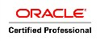
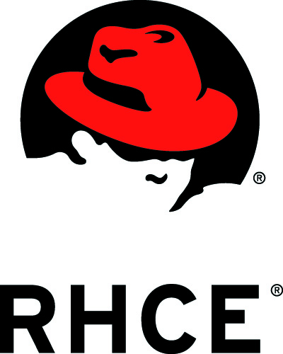
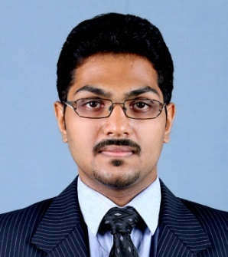
RENO

Reno.80522@2freemail.com

OBJECTIVE

To secure a challenging position in a modern, innovative and dynamic organization where I can use my logical and reasoning abilities and technical, communication and interpersonal skills effectively and grow along with the organisation.

PROFESSIONAL SYNOPSIS

- Red Hat Certified Engineer (Certification number: 130-009-905)
- Knowledge skills on Samba, FTP, HTTP, Remote login, LDAP, ISCSI.
- Oracle 10g Certified Professional (Certification number: SR3151175)
- Knowledge skills on RMAN, Database Backups, Report Generating.
- Knowledge on projects with PL/SQL programming
- Experienced in Management Information System (MIS).
- Experienced in customer support services for clients based in Australia.

WORK EXPERIENCE

FRAGOMEN IMMIGRATIONS SERVICES, India (February 2013 – May 2013)
Process Executive – Database Support

- Troubleshooting and maintaining Database FLV-GVS
- Handling troubleshooting issues about database records for all global offices
- Generate, maintain and analyze client requirement needs
- Creation of forms and reports to clients
- Good knowledge on SQL queries
- Develop and document technical processes
- Generate, maintain, analyze and present weekly/monthly Client Service reports

Professional Skill:
Database: MS Excel, MySQL Server
Other Software Packages: LOTUS Notes, MS Office 2003, 2007
Charter Mercantile Agency, India (January 2010 – February 2011)
Management Information Systems Engineer

- Design reporting formats to provide accurate information in a clear and concise manner.
- Review the history of current reporting for better time utilization, consistency and accuracy.
- Monitor implementation of MIS processes and evaluate their effectiveness.
- Standardize similar reports across clients, departments and teams.
- Data collection, analysis and reporting as required. (I.e. Data/ Field Formatting, Data Storage, and report Generation)
- Preparing Workflow MIS reports and forecasting workforce availability based on data collected and trend analysis.

Professional Skill:
Database: MS Access, Excel, MySQL Server
Operating System: Windows XP, Linux (Ubuntu)
Other Software Packages: MS Office 2003, 2007

Customer Support Executive (September 2008 – December 2009)
Client: Optus Communications Private Limited,Australia.

- Maintaining the daily CSAT ,AHT ,SVL of the entire process as per client satisfaction
- Sending the reports and feedback to the clients and the concerned team on a daily basis
- Take responsibilities for escalated concerns of the customers and give the ultimate solution to the concern of the customer

EDUCATIONAL QUALIFICATIONS

Course | Institute | University/Board
B.Tech. (EC) | College of Engineering,  Chengannur, India | Cochin University of Science and Technology, Kerala, India
A.I.S.S.C.E | United Indian School, Kuwait | Central Board of Secondary Education, India
A.I.S.S.E | United Indian School, Kuwait | Central Board of Secondary Education, India

PERSONAL DETAILS

Nationality : Indian
Languages Known : English, Malayalam, Hindi and French.
Visa Status : Visit Visa

DECLARATION

I hereby declare that the information furnished above is true and correct to the best of my knowledge and belief

Place: Dubai Reno

